

**RESEARCH AND DEVELOPMENT OF AN OPEN SOURCE MEAL PLANNER WEB APPLICATION**

by

DAVID CHILANZI SENSENTA

STUDENT NUMBER: **044-348**

PHONE NUMBER DETAILS: **+260966851434, +260771923958.**

EMAIL: **Chilanzi11037@gmail.com**

A Dissertation

Submitted to BUSINESS AND INFORMATION TECHNOLOGY DEPARTMENT,

CAVENDISH UNIVERSITY ZAMBIA.

In Partial Fulfillment of the Requirements

For THE AWARD OF BACHELOR OF ARTS IN COMPUTER SCIENCE.

**DECLARATION**

I affirm that this submission represents my own work and, to the best of my knowledge and belief, it does not contain any previously published or written material by another individual, nor does it contain substantial portions that have been accepted for the attainment of any other degree or diploma from the University or any other Institute of higher learning. In cases where I have referenced external sources, proper acknowledgment has been given within the text.

………………………………………

Student Signature

(David Chilanzi Sensenta)

…………………………….

Date

**Supervisors Declaration**

This Thesis is submitted for examination with my full knowledge and acceptance of the thesis:

……………………………………. Supervisor Signature (Mr. Henry Sinkala)

……………………………………..

Date

**ABSTRACT**

This research explores the utilization of technology, including web technologies, as a means to improve nutrition and foster innovation, with a specific focus on addressing nutritional challenges in Zambia. Through the integration of web-based platforms, such as websites and online applications, a comprehensive and accessible nutrition intervention was developed. These technologies facilitated the dissemination of educational resources, personalized meal planning, and tracking tools, empowering individuals in Zambia to make informed dietary choices. The study emphasizes the trans formative potential of technology in enhancing nutrition and driving innovation, underscoring the importance of leveraging digital tools to address regional nutritional needs and improve overall health outcomes.

**ACKNOWLEDGMENT**

First and foremost, I express my gratitude to the Almighty God for the blessings bestowed upon me thus far. Throughout my journey at the University, your guidance has made it much easier for me.

I would like to seize this moment to extend my heartfelt appreciation to all the faculties and mentors who played a significant role in my growth and development. I want to give special thanks to Mr. Henry Sinkala, my supervisor, who provided invaluable suggestions and feedback that helped me successfully complete my first research project. His guidance ensured that I stayed on the right track throughout the process.

I would also like to express my acknowledgments to all the lecturers in the Computer Science department at Cavendish University, School of Bcom, for their unwavering dedication in providing the utmost quality of education.

Lastly, I extend my heartfelt gratitude to everyone who contributed to the success of this project. Your support and contributions have been invaluable. Thank you all, and may God bless each and every one of you.

1.0 CHAPTER ONE: INTRODUCTION 8

1.0.0 Introduction 8

1.1 Background to the study 8

1.2 Problem statement 9

1.3 Purpose of the study 9

1.4 Objectives of the study 9

1.4.1 General objective of the study 9

1.4.2 Specific Objectives of the study 9

1.5 Research Questions 10

1.6 Significance and justification of the study 10

1.8 Methodology 11

2.0 CHAPTER TWO: LITERATURE REVIEW 11

2.1 Introduction 11

2.2 Theoretical framework 11

2.3 Previous studies and Implemented systems 12

2.3.1 Developing Countries 12

2.3.1.1 FAO promoting health diet 12

2.3.2 Developed Countries 13

2.3.2.1 online consultation websites for nutrition guide 13

2.3.2.2 Mobile Application (e-balance) 14

2.4 Research gaps 14

2.5 Research variables arising from the literature review 15

2.6 Conclusion 15

3.0 CHAPTER THREE: METHODOLOGY AND DESIGN 16

3.1 Introduction 16

3.1.1 General Design of the Web-app 16

3.2 Methodology Adopted 19

3.2.1 Privacy And Security 20

3.2.2 Validation And verification 20

3.2.3 Site Map 20

3.2.4 Use Case Diagram 21

3.2.5 Flow Chart Diagram 21

3.2.6 UI Design 22

3.2.6.1 Low Fidelity wire frames of Healthy-bites 23

3.2.6.2 High Fidelity wire frames of Healthy-bites 26

3.3 Research design 27

3.3.1 Research Strategy 28

3.5 Source of data 28

3.5.1 Primary data 29

3.5.2 Secondary data 29

3.6 Sampling methods 29

3.7 Sampling Techniques 29

3.8 Data Collection Techniques 30

3.9 Reliability / Validity 30

3.10 Ethical Considerations 30

3.10.1 Standardization: 31

3.10.2 Security 31

3.11 Limitation of Study 31

4.0 CHAPTER FOUR: IMPLEMENTATION AND TESTING 32

4.1Introduction 32

4.2 Landing page (Home Page) 32

4.2.1 Hero section 32

4.2.1.0 Html And tailWind Css Code 32

4.2.2 How it Works Section 34

4.2.2.1 Html And tailWind Css Code 34

4.2.3 Features Section 36

4.2.3.2 Html And tailWind Css Code 36

4.2.4 Consultation Section 38

4.2.2.3 Html And tailWind Css Code 38

4.3 Details Entry Page (form fill in Page) 40

4.3.1 Html And tailWind Css Code 40

4.3.2 Javascript (logic) 41

4.4 Meal page (Randomized meals Page) 43

4.4.1 Html And tailWind Css Code 43

4.4.2 Javascript (logic) 58

4.5 Returning Users page (special code Page) 80

4.5.1 Html And tailWind Css Code 80

4.5.2 Javascript (logic) 83

5.0 CHAPTER FIVE: CONCLUSION, IMPLICATIONS AND RECOMMENDATION 84

5.1 Introduction 84

5.2 CONCLUSION 84

5.3 IMPLICATIONS 86

5.3.1 positive implications 86

5.3.2 negative implications 87

5.3 RECOMMENDATIONS 87

REFERENCE 88

APPENDIX 90

User Manual 90

Landing page 90

Get Started Page 91

Meal plan Page 92

Meal code page 93

Questionnaire and interview Questions 94

Questionnaire nutritionist 94

interview Questions nutritionist 95

Interview Questions Citizens 96

# **1.0 CHAPTER ONE: INTRODUCTION**

## 1.0.0 Introduction

Zambia a developing country faces many challenges. One of these challenges is the poor eating habits of many Zambians, who often struggle to access or afford a varied and nutritious diet. Many Zambians consume foods processed foods and consume fewer fruits and vegetables, leading to a range of health problems I.e obesity, diabetes, and heart disease.

To address this problem, I propose the development of a web application that uses a random generation algorithm to help users create a balanced diet for a week. The web app will take into account the user's food preferences, allergies and other restrictions as well as special conditions and generate a randomized diet plan that is nutritionally balanced and easy to follow. The goal of this web app is to improve the health and eating habits of Zambians by providing them with an easy, accessible and convenient tool for following a healthy daily diet.

Technology has created many solutions to existing problems due to it being scalable, accessible and offering personalization. A web app which is a web technology can be accessed by a large number of people from any location with a reliable internet connection, The random generation algorithm will allow the creation of personalized diet plans that are tailored to individual preferences and requirements as well as create random meals to make it engaging.

## 1.1 Background to the study

Zambia has put in place several steps to promote good healthy eating habits and ways to address the issue of poor nutrition among its population, these are :

1. The National Food and Nutrition Commission (NFNC) is responsible for coordinating and implementing nutrition policies and programs, with a focus on addressing the nutrition needs of vulnerable groups.
2. The Scaling Up Nutrition (SUN) Movement is a global effort to improve nutrition outcomes, and Zambia is a member of this movement. Through its membership, Zambia has access to resources and technical assistance to support its nutrition programs and address specific issues such as diabetes and childhood obesity.
3. The Ministry of Agriculture and Livestock encourages the production of nutritious food in the country, focusing on small-scale farmers as well as promoting sustainable agriculture.
4. Community-based nutrition programs run by NGOs and CBOs also focus on promoting healthy eating habits and addressing specific issues such as diabetes, through nutrition education and awareness-raising campaigns.

## 1.2 Problem statement

Despite all the efforts made by the government and other social organizations in promoting healthy eating habits in Zambia, the country continues to face significant challenges in this area, particularly for diabetics and children. This research and development aim to investigate the causes of these challenges and propose a solution in the form of a web-based application that uses a random generation algorithm to help users create balanced diets for a week (7 days).

## 1.3 Purpose of the study

To research and develop a web-based system that can help generate a balanced diet for Zambians, the main focus is addressing the problem of poor nutrition in Zambia.

## 1.4 Objectives of the study

### 1.4.1 General objective of the study

To develop a web application, code-named "HealthyBites!," that helps users in Zambia generate a balanced diet for a week (7 days) using a random generation algorithm, to address the problem of poor nutrition in the country, particularly among high-risk groups such as diabetics and children.

### 1.4.2 Specific Objectives of the study

1. To understand the current state of nutrition in Zambia and the challenges faced by the population in following a healthy eating regimen.
2. To investigate the effectiveness of using technology as a solution to improve nutrition in Zambia.
3. To design and develop a user-friendly web application that generates a personalized, balanced diet for users based on their dietary restrictions and preferences.
4. To evaluate the effectiveness of the developed web application in promoting healthy eating habits and improving nutrition among users.
5. To identify any limitations or areas for improvement in the web application and suggest recommendations for future work.

## 1.5 Research Questions

1. What is the current state of nutrition in Zambia and what are the challenges people are facing in following a healthy diet?
2. What are the existing solutions to improve nutrition in Zambia and what is their effectiveness?
3. How can technology be used to improve nutrition in Zambia?
4. Is the use of technology an effective solution to promoting healthy eating habits and improving nutrition in Zambia?
5. How can a user-friendly web application be designed and developed to promote healthy eating habits and improve nutrition among Zambian people?
6. What are the key features and functionalities of a successful web application for promoting healthy eating habits and improving nutrition in Zambia?
7. How effective is the developed web application in promoting healthy eating habits and improving nutrition among users in Zambia?
8. What is the user feedback and experience with the web application and what is the impact of the application on their nutrition and health status?
9. What are the limitations or areas for improvement in the web application and what changes need to be made to make it more effective in promoting healthy eating habits and improving nutrition among Zambian people?
10. What are the best practices and recommendations for future work to improve the web application and enhance its impact on promoting healthy eating habits and improving nutrition in Zambia?

## 1.6 Significance and justification of the study

The significance of this study lies in the potential impact it can have on improving the nutritional status of individuals in Zambia, Among high-risk groups (diabetics and children). With the increasing prevalence of diet-related health issues and the lack of accessible and user-friendly meal-planning resources, there is a pressing need for a web-based meal-planning application or Web app that utilizes advanced web technologies to make healthy eating more convenient and achievable. By carrying out this research and developing the web app, I aim to address this need and contribute to the well-being of the Zambian population.

## 1.8 Methodology

This will involve a combination of quantitative and qualitative methods to effectively gather and analyze data within a specific time frame.

1. A literature review will be conducted to gather information on current meal planning applications and the nutritional status of individuals in Zambia, particularly among high-risk groups such as diabetics and children.
2. A literature review will be conducted to gather information on current meal planning solutions developed countries have implemented.
3. Interviews will be conducted with healthcare professionals particularly nutritionists to gather their views on the current state of nutrition in the country and the potential impact of a web-based meal planning web app.
4. The prototype will be developed and implemented.

The use of a combination of methods and a focus on both the user and healthcare professional perspectives will provide a comprehensive understanding of the problem and the potential impact of the proposed solution within the given time frame.

# **2.0 CHAPTER TWO: LITERATURE REVIEW**

## 2.1 Introduction

The literature review is a crucial element of any research project, including this dissertation. It serves to offer an overview of the existing research in the field, pinpoint gaps in current knowledge, and create a foundation for the proposed research. By consolidating previous studies, analyzing the connections between variables, and assessing the necessity for further research, the literature review establishes a framework of knowledge and understanding that will inform the study's design and implementation. This section of the dissertation will delve into relevant literature, theories, and models related to the research topic.

## 2.2 Theoretical framework

According to Wakefield, Zgibor, & Kullgren (2016), promoting healthy eating through the integration of technology is the focus of the Health Information Technology (HIT) Model. This model comprises three primary components: the individual, the technology, and the environment. The individual component encompasses an individual's attitudes, beliefs, and motivation toward healthy eating. The technology component includes the features and functions of technology such as mobile apps or wearable devices. The environment component refers to the context in which the individual and technology interact, such as social support networks or access to healthy food options.

By taking into account all three components, the HIT Model offers a comprehensive perspective on how technology can support healthy eating. For example, the willingness of an individual to use technology that tracks food intake will be influenced by the ease of use and meaningful feedback provided by the technology. In addition, having access to healthy food options and support from others can help promote healthy eating habits.

The HIT Model can guide the design and implementation of health technology interventions aimed at promoting healthy eating. It emphasizes the importance of considering the individual's characteristics, technology features and functions, and environment to create effective and sustainable health technology interventions.

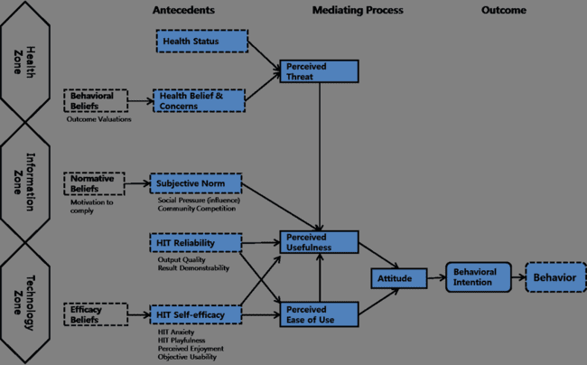

## 2.3 Previous studies and Implemented systems

### 2.3.1 Developing Countries

#### 2.3.1.1 FAO promoting health diet

Developing countries promote or implement good diets through organizations that help in guiding African nation on various food guidelines one of these organizations being FAO , It is an international organization that focuses on eradicating hunger, improving nutrition, promoting sustainable agriculture, and ensuring food security worldwide. The FAO was established in 1945 and is headquartered in Rome, Italy. The primary goals of the FAO include Eliminating hunger, Improving nutrition, Enhancing agricultural productivity, Sustainable use of natural resources etc.

According to the Food and Agriculture Organization of the United Nations (FAO) (2021), Zambia has received several solutions to encourage healthy eating habits. The FAO has made dietary guidelines accessible through nutrition education and awareness-raising activities. The organization has collaborated with the Zambian government to integrate the guidelines into national policies and programs, as well as promote the development of food-based dietary guidelines and food composition databases.

Further, the FAO has partnered with various entities to strengthen the food systems in Zambia. which, includes promoting diverse and locally produced foods, making healthy foods more available and affordable, and creating food fortification programs to improve the nutrient content of staple foods.

### 2.3.2 Developed Countries

### 2.3.2.1 online consultation websites for nutrition guide

After doing some careful information gathering on how developed countries implement eating health or nutrition guide,its of note that developed countries use the internet ,websites to be precise to offer consultations to its public on how to carry out good eating habits and it has its positives which are as follows.

**Accessibility**: Online consultations provide easy access to professional nutrition advice for citizens. They eliminate the need for physical appointments and allow individuals to seek guidance from the comfort of their homes. This accessibility is particularly beneficial for people with mobility issues or those living in remote areas where access to healthcare professionals may be limited.

**Convenience**: Online consultations offer flexibility in terms of scheduling and communication. People can book appointments at their convenience and engage in discussions with nutritionists or dietitians through video calls, chat platforms, or email. This flexibility accommodates busy lifestyles and allows individuals to fit consultations into their schedules more easily.

**Personalization**: Online consultations enable personalized nutrition guidance. Individuals can share their specific dietary preferences, health concerns, and goals with nutrition professionals, who can then tailor advice accordingly. This personalized approach enhances the effectiveness of the guidance provided and increases the likelihood of individuals adhering to dietary recommendations.

**Technology and Tools**: Online consultations often utilize various technological tools and resources to enhance the experience and effectiveness of the guidance. These may include mobile apps, web-based platforms, and online tracking tools that help individuals monitor their food intake, track progress, and receive real-time feedback. Such tools can empower individuals to make informed decisions about their dietary habits.

**Cost-effectiveness**: Online consultations can be cost-effective compared to in-person consultations. They eliminate the need for travel expenses and reduce administrative costs, making nutrition guidance more affordable and accessible to a wider population.

**Data Collection and Analysis**: Online consultations allow for efficient collection and analysis of data related to individuals' dietary habits. By leveraging technology, nutrition professionals can track and evaluate trends, patterns, and outcomes across a large population. This information can be used to improve public health initiatives, develop evidence-based interventions, and refine dietary guidelines.

### 2.3.2.2 Mobile Application (e-balance)

Developed countries have also employed a number of mobile application to aid people in eating health an example of this app is e-balance developed by university student .Mobile applications are very convenient way in this internet world because they are easily accessed due to the fact that almost everyone in a developed country owns a smart phone.

mobile apps have become integral to the daily lives of people in developed countries. They offer convenience, accessibility, and efficiency in various aspects, including information access, communication, financial management, health monitoring, education, transportation, and entertainment. Mobile apps have transformed the way people interact, work, learn, and entertain themselves, enhancing overall quality of life.

## 2.4 Research gaps

* Limited research on food habits and preferences of specific demographic or groups in Zambia, such as pregnant women, children, or elderly individuals.
* A lack of research on the effectiveness of nutrition education and awareness programs in promoting healthy eating habits in Zambia, particularly in rural or low-income communities.
* Limited research on the cultural and social factors that influence food choices and eating behaviours in Zambia, and how these factors can be addressed to promote healthier diets.
* Insufficient research on the potential impact of climate change on food security and the availability of nutritious foods in Zambia.
* Limited use of web technology to solve medical issues
* Limited research on the use of technology in promoting healthy eating habits and improving nutrition in Zambia, and how best to design and implement digital interventions that are accessible and effective for different populations.

## 2.5 Research variables arising from the literature review

* Dietary intake: This variable could include the amount and types of foods consumed by individuals, as well as any nutritional deficiencies that may be present in the population.
* Cultural and social norms: These variables could influence what foods are considered acceptable or desirable to eat, and how meals are prepared and consumed.
* Availability and access to healthy foods: This variable could include the physical availability of healthy foods in Zambia, as well as the affordability and accessibility of these foods to different segments of the population.
* Technology adoption and usage: This variable could include the extent to which technology is currently being used in Zambia to support healthy eating, as well as any barriers to adoption or usage.
* Health outcomes: This variable could include measures of health status or disease prevalence that are related to diets, such as rates of obesity, malnutrition, or chronic diseases.

## 2.6 Conclusion

The Health Information Technology (HIT) Model provides a comprehensive approach to using technology to support healthy eating by considering individual characteristics, technology features, and the environment which is a good model to use for combining technology and health.

They are many schemes put in place to try to promote good eating habits, on the local front The FAO has already implemented various solutions to promote healthy eating in Zambia, such as making dietary guidelines accessible and strengthening the food systems. and on the international front other studies like the study by Naimark et al. showed the potential of a web-based app in promoting healthy lifestyles. However, More research is needed to understand specific groups' dietary habits, the effectiveness of nutrition education, cultural and social factors influencing food choices, climate change's impact on food security as well of using technology to promote healthy eating.

In general, the literature review forms the basis of knowledge that will guide the proposed research's design and implementation. The study's results will help address the identified research gaps and contribute to the existing literature on promoting healthy eating in Zambia. Policymakers, public health practitioners, and other stakeholders working towards promoting healthy eating in Zambia will find the research findings valuable.

# **3.0 CHAPTER THREE: METHODOLOGY AND DESIGN**

## 3.1 Introduction

In this chapter, I outline the methodology and design picked to address the research questions and achieve the research objectives. it presents a detailed account of the research approach, design, data collection methods, data analysis techniques, and ethical considerations. The thinking behind the chosen methodology and design is elaborated and explained in detail, as well as the strengths and limitations of the approach. The chapter will be organized into several sections to provide a clear and comprehensive overview of the study's methodology and design.

### 3.1.1 General Design of the Web-app

It is essential to understand what the web-app will offer and what category it falls inro which helps developers pick the algorithms or platforms and tools that will be used to develop the ui and architecture as well as language. At the same time, it also aids the end-users in understanding what to expect from the system. The general essence of this web-app is to get users detail or condition and create a balanced 7 day meal plan without forcing user into subscribing for the service. meaning its a tool that helps guide users make healthy food decisions.

The researcher utilized the following tools in the design of this Web-app:

* **HTML**: stands for Hypertext Markup Language. It is a markup language used to create and design web pages. HTML consists of a series of tags and attributes that are used to structure and format the content of a web page, such as headings, paragraphs, images, links, forms, and more. When an HTML file is loaded by a web browser, the browser reads the file and renders it as a web page, displaying the content according to the instructions provided by the HTML tags and attributes.
* 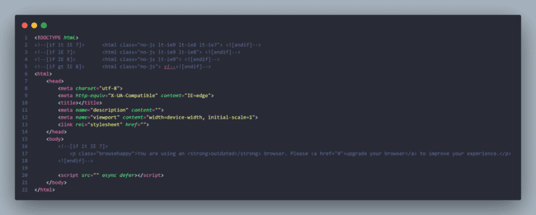**TAILWIND CSS:** utility-first CSS framework that provides pre-defined CSS classes that can be used to rapidly build user interfaces without writing custom CSS. It is designed to make it easy to create responsive and customizable designs with minimal effort. With Tailwind, you can build complex UI components quickly by composing small, reusable utility classes that can be applied directly in your HTML.

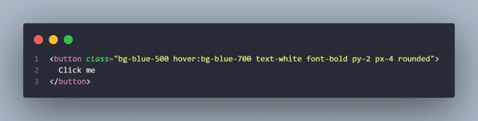In this example, the button element has several Tailwind CSS classes applied to it:

1. bg-blue-500: Sets the background color to a shade of blue.
2. hover:bg-blue-700: Changes the background color to a darker shade of blue when the user hovers over the button.
3. text-white: Sets the text color to white.
4. font-bold: Sets the font weight to bold.
5. py-2: Adds padding of 0.5rem (or 8px) to the top and bottom of the button.
6. px-4: Adds padding of 1rem (or 16px) to the left and right of the button.
7. rounded: Rounds the corners of the button.

* **JAVASCRIPT**: is a high-level, interpreted programming language that is commonly used to create interactive web pages and dynamic web applications. It was created in 1995 by Brendan Eich while he was working at Netscape Communications Corporation. JavaScript allows developers to add functionality to web pages, such as form validation, dynamic styling, and animations, and also enables the creation of complex web 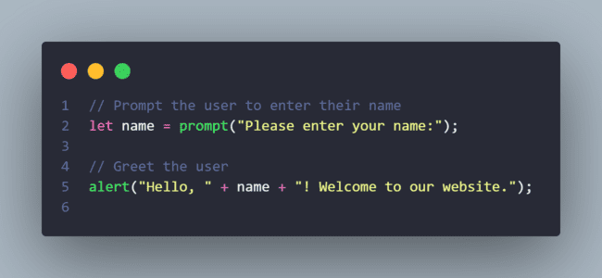applications,

This script uses the prompt() function to display a dialog box where the user can enter their name, and the alert() function to display a message welcoming them to the website.

* **LUNACY**: free graphic design software developed by Icons8. it's designed to work seamlessly with Icons8's extensive library of icons and other graphical assets. Lunacy is primarily aimed at UI/UX designers and developers
* **GIT:**  is a distributed version control system used for tracking changes in source code during software development. It allows developers to collaborate on projects and keep track of different versions of their code.
* **GITHUB:** a web-based platform that uses Git for version control and collaboration. It provides a place for developers to store and share their code with others, as well as to collaborate on projects with other developers**.**
* **VS CODE:** Visual Studio Code (VS Code) is a source code editor developed by Microsoft for Windows, Linux, and macOS. It includes support for debugging, syntax highlighting, intelligent code completion, snippets, code refactoring, and embedded Git. It also includes extensions that can be added to provide additional features and support for additional programming languages.

## 3.2 Methodology Adopted

the research will follow the normal flow of software development by implementing the Software Development Life Cycle (SDLC) model (**waterfall model**), which involves several stages, starting with the

• Planning stage: In this stage, we establish the goals and objectives of our research, and identify the scope of our study. We review existing literature on particular topics, consult with nutrition experts, and use Google questionnaires to gather relevant data.

• Analysis stage: we will gather and analyze data related to the nutritional content and quality of food options available to consumers. We will use a variety of data sources, such as nutritional databases and Google questionnaires, to help us gain a better understanding of the current eating habits of Zambians.

• Design stage will involve the development of our research framework and methodology, where we will carefully design our study to ensure it is both valid and reliable. We will use appropriate sampling techniques and statistical analysis to ensure the accuracy of our findings.

• Development stage: where we will begin collecting and analyzing data. We will use Google questionnaires to gain insight into consumer attitudes and behaviours related to healthy eating.

• Testing stage: will involve the validation of our research findings and the identification of any potential biases or limitations in our study. We will conduct thorough data analysis to ensure the accuracy and validity of our findings and address any potential issues that may arise.

Deployment stage, we will disseminate our research findings to key stakeholders, such as policymakers, healthcare providers, and nutritionists. We will provide recommendations for improving healthy eating habits, and promote the adoption of evidence-based interventions to improve the nutritional status of 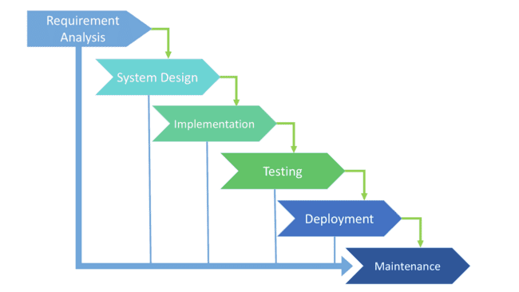consumers.

## 3.2.1 Privacy And Security

* 1. Since the system does not collect important user data and does not implement databases, it reduces privacy concerns and security risks. This type of system is commonly referred to as a "stateless" or "client-side" application, as it does not store any user-specific information on the server-side. It relies on client-side processing, meaning the user's device handles the computations and stores any necessary data locally. This reduces the risk of data breaches and unauthorized access to personal information.

## 3.2.2 Validation And verification

* 1. Because this system aims to be a lightweight system and does not implement a data base ,a system that aims to provide previous meal plans will be implemented and has the following steps
  2. **Code Generation:** After initial use, the system can generate a unique code for each user. This code serves as a reference to retrieve their previously generated meal plans. The code can be a combination of alphanumeric characters or a randomly generated string.
  3. **Code Entry**: When a returning user visits the system, they can enter their unique code in a designated field. This code acts as a validation measure to ensure that only authorized users can access their specific meal plans. The system can include a validation mechanism to verify the entered code.
  4. **Access to Previous Meal Plans:** Upon successful code validation, the system can grant the user access to their previously generated meal plans. This can be achieved by retrieving the meal plan data associated with the entered code and displaying it to the user.

## 3.2.3 Site Map

A site map is simply a map on a website or web application that simply outlines the most important pages that a particular web application or website has ,as well as the connection between the important pages .

* 1. **Home page :** The home page is the first page the user will first see which will have the important call to action buttons on any site or web application.
  2. **Detail page** : This will be the page where he user enters his or her details in order to generate a meal that suits there particular details.
  3. **Code page** : This is the page that returning users will access in order to enter code.
  4. **Meal page** : this is the page with the 7 day meal plan generated for the user.
  5. **Guide p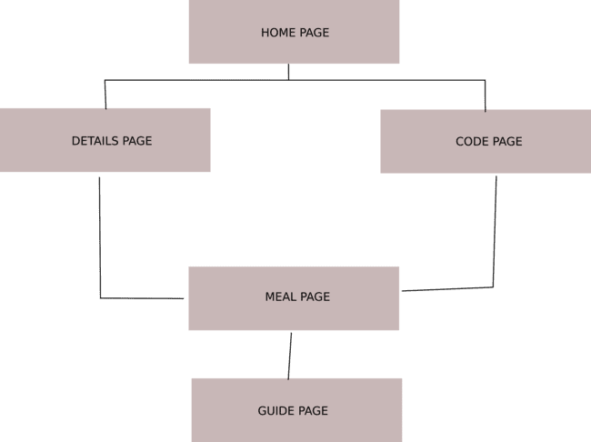age** : the page with guide of how to use and read the web application .

## 3.2.4 Use Case Diagram

* 1. In the Unified Modeling Language (UML) A use case diagram, just as the name suggests, is a diagram that takes key interest in representing the system’s users and their interactions. However, it is vital that the Use case diagram is as effective as possible as it influences the
  2. 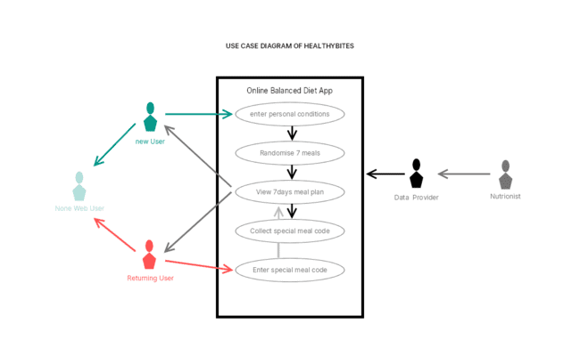overall understanding of the system’s architecture

## 3.2.5 Flow Chart Diagram

* 1. A Flowchart demonstrates the Operation of the Web Application design that was followed. a flowchart is a diagram that represents a logical sequence depicting a process in a computer algorithm or a system.

## 3.2.6 UI Design

* 1. UI design involves developing intuitive and visually appealing interface components that facilitate seamless user interaction with websites, applications, or other computer systems. The ultimate goal of UI design is to enhance the user experience by making it easy and enjoyable to use these systems. since this web-app is made to be used as a tool at any time mobile first approach to the user interface design was adopted because the majority of individuals who are going to use this app are going to access it using the mobile phone

### 3.2.6.1 Low Fidelity wire frames of Healthy-bites

This is a simple wire frame is a basic representation of how the product is going to look and feel and captures only the essential features of a product like the structure using simple tools like 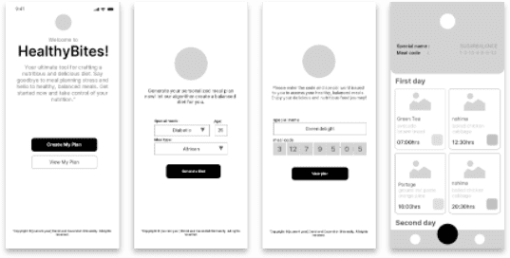pl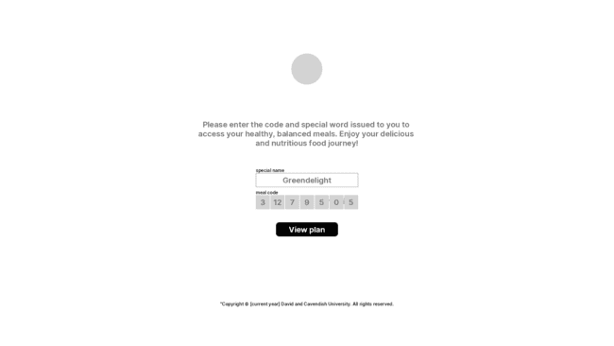ace holder text ,monochromatic colors etc and are the early stages of design.

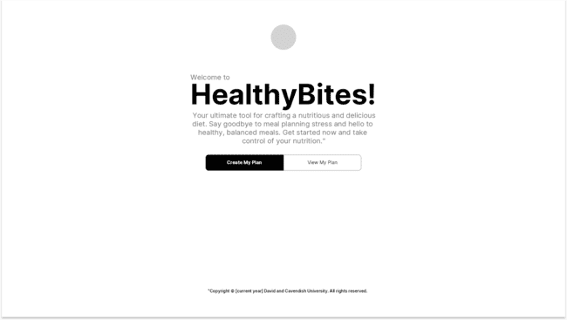Figure of a low fidelity wire frame homepage

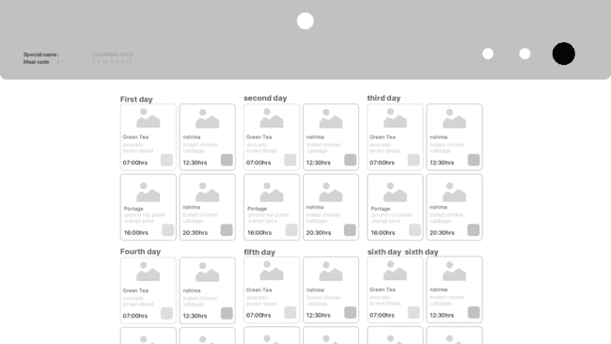Figure of a low fidelity wire frame meal page

### 3.2.6.2 High Fidelity wire frames of Healthy-bites

This is a high resolution design of the product that close to the end products look and feel .the structure is perfected and color scheme as well as assets are applied to the product in order to produce a well designed end product.

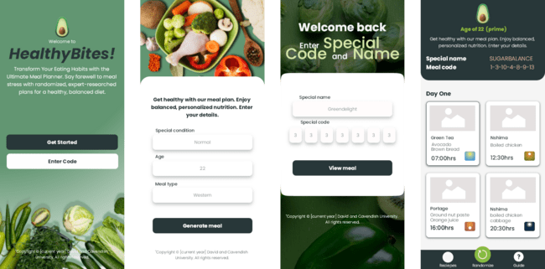Figure of a high fidelity wire frame 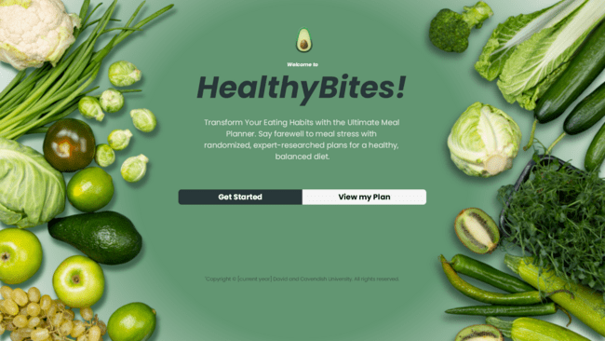mobile view

Figure of a high fidelity wire frame homepage

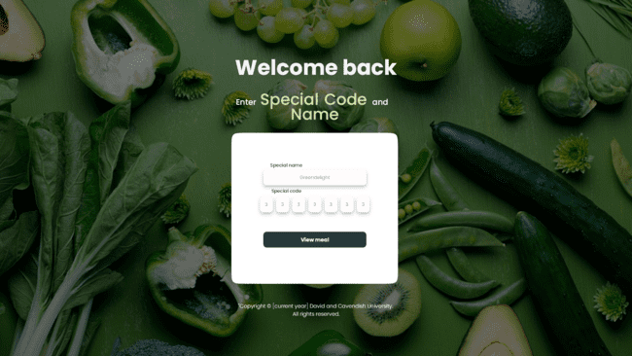Figure of a high fidelity wire frame code page

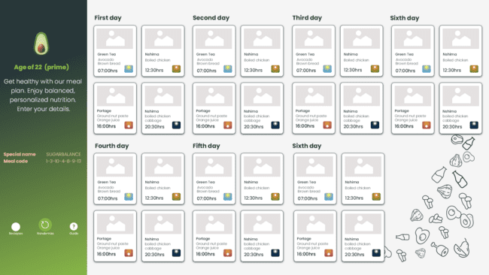Figure of a high fidelity wire frame meal page

## 3.3 Research design

During the research, there are two primary methods or research design types: exploratory and conclusive research. The former seeks to identify and explore potential problems or situations to gain insight and understanding, while the latter aims to test specific hypotheses and examine relationships. As we dive into the topic of healthy eating and eating habit by the Zambian people concerning healthy eating for the Healthy Bite web application, it's critical to note that the research design falls under the category of descriptive research, which is used to describe the characteristics of population, organizations, or markets. A descriptive research design is the most suitable approach for the Healthy Bite app because its the method that employs quantitative data to measure the factors influencing healthy eating behavior.

### 3.3.1 Research Strategy

Will begin with a thorough literature review to help formulate research questions .that will be the basis of the research, from the response or feedback that will be obtained from the questionnaire, responses with similar attributes will be put together to form personas, these will be used to gain a better understanding of the problem at hand. By using this problems will be identified and a user-centered approach to solving the problems will be carried out, the research will focus on solving the personas problems, According to E.Navoseltseva (2018) "User-centered design (UCD) is an iterative design process in which designers and other stakeholders focus on the users and their needs in each phase of the design process. UCD calls for involving users throughout the design process via a variety of research and design techniques to create highly usable and accessible products for them." therefore this approach is effective in designing solutions to problems. Finally, the data collected from the personas will be analyzed through the use of frequency tables, and conclusions and recommendations will be drawn based on the findings.

3.4 Research variables

This web app will be an online application hosted online, this is so that everyone can access it online without having to install it onto their devices meaning everyone has the access to it no matter how old the device they are using to access the web app. it has no hardware requirements only access to the internet Requirement.

Further research shows that not everyone in Zambia has good access to the internet however the proposed system will not require account login so that even healthcare centers can create balanced meals for individuals on the fly without stressing too much about registration.

Returning users show that they want to continue passing saved details because this system has no registration and no need for the database to store user information, therefore, a model that works around this will be developed since the tool is intended to be a guide that helps people plan healthy meals.

## 3.5 Source of data

The source of data for the study has been a major concern, therefor both primary and secondary modes of data collection were utilized to overcome the potential weaknesses of intrinsic biases and problems that may arise from a single method and theory of studies, the research employed methodological triangulation, which involved reviewing interviews, observations, and questionnaires.

### 3.5.1 Primary data

The majority of the data collected was from Questionnaire issued to the local nutritionists at a small local clinic and a big hospital. The majority of the information from this Questionnaire stated that eating healthy in a Zambian household is a luxury because most of the common Zambian people leave below the poverty line therefore they eat what their pockets can afford to eat and do not know that even local cheap food can be structured in a balanced format. One nutritionist also stated that most of the people who access his services at the hospital are those who are pregnant or are in critical condition if a nutritionist guide is not found which should not be the case. the observation from all this is that most Zambians do not focus on healthy eating.

### 3.5.2 Secondary data

The secondary data was from analyzing the old system and Literature available from Zambian nutrition books available in Zambia The Internet's e-books and blogs were helpful in the collection of information in a quest to develop the web-based online web application system. Interviews also assisted in collecting the secondary data as the number of selected hospital patients (pregnant women, diabetics and children's parents) were interviewed to obtain information on the ways that they get balanced meals and how they pick balanced schedules.

## 3.6 Sampling methods

It is important to structure ways to collect information because it helps ensure that the data collected is relevant, accurate, and reliable.

* Questionnaires
* Interviews
* Observation
* Analysis of old System

## 3.7 Sampling Techniques

In this research, two sampling techniques were used

* **Stratified Sampling**: this involves dividing the population into subgroups (or strata) and selecting individuals from each subgroup in proportion to their representation in the population.
* **Snowball Sampling**: involves selecting individuals who can refer or introduce other individuals who fit the criteria for the study.

## 3.8 Data Collection Techniques

Three techniques were used to collect information from nutrition professionals and the general public. These includes

* Observation
* Interviews
* Questionnaires

**Observation**: the observation on how Zambians and eating healthily is that they tend to avoid it and only pay attention to healthy eating when instructed by the doctors when their health worsens due to bad eating habits and some assume it is expensive to eat right

**Interviews**: A selected few individuals (diabetics, pregnant women and parents ) from the hospital were interviewed to obtain information on ways they get guides on a well-balanced diet and how easy they find these guides. Most of them stated that the hospital nutritionist guides them on what to eat and most of the time it's a rushed process, they also noted that they would want an easy guide that is easily followed than having to have the same meals issued and standing in line for a detailed plan.

**Questionnaires**: Basically, questionnaires were issued to a few nutritionists that provided the views of the nutrition on how nutrition is being viewed among est the local public The majority stated that nutrition information is easy to find but the foods that are recommended in these nutrition guides seem tailored for the west and locals tend to assume its expensive to eat right since most leaves bellow the poverty line.

## 3.9 Reliability / Validity

The data collected has shed some light on what best can be done to create the system. It has surely provided reliable information on ways to implement said system because most of the information was obtained from individuals that are closely related to Zambian society and professionals who have been involved in promoting nutrition took time to provide the necessary information.

## 3.10 Ethical Considerations

Computer ethics is a discipline in computer science that addresses ethical concerns that arise from computer technology. It involves examining the nature and social implications of computer technology, as well as developing ethical guidelines for its use. Computer ethics also covers the impact of computer technology on personal and social policies. The following are some of the factors that need to be considered.

### 3.10.1 Standardization:

These are established global or regional standards for addressing problems or designing ICT systems, which all ICT stakeholders are expected to comply with. Standardization aims to ensure that there is a universally recognized level of ICT standards, particularly in terms of technology usage.

### 3.10.2 Security

ICT security is an important aspect of any ICT project or establishment, measures and Standard practices must be implemented to ensure the protection of data and information. All stakeholders must follow established security procedures and standards to fully appreciate ICT. Measures such as password usage, firewalls, and encryption can enhance security. Companies may require clients to provide personal information to protect their clients from theft and abuse.

## 3.11 Limitation of Study

1. Data collection limitations: The study faced challenges in accurately collecting data on the dietary habits and nutritional status of individuals in Zambia, which can affect the validity of the findings.

2. Cultural and social factors: The cultural and social norms such as income, food availability, etc surrounding food and eating habits in Zambia impact the effectiveness of the web application in promoting healthy eating.

3. Technology adoption: The study also faced challenges related to technology adoption as most Zambian areas are not familiar with using web applications or do not have access to the technology needed to use the application especially rural-based area individuals.

4. Limited sample size: The study has a limited sample size because the time for developing reliable samples is extremely limited, which may have affected the generalization of the results.

5. Data privacy and security: The study must consider data privacy and security concerns, as individuals may not be comfortable sharing personal information such as dietary restrictions.

6. Resource constraints: The study may face budget and resource constraints, which could impact the quality and accuracy of the results

# **4.0 CHAPTER FOUR: IMPLEMENTATION AND TESTING**

## 4.1Introduction

This chapter presents the results of the implemented program and its functionality, focusing on the important capabilities that have been designed to answer the questions raised from the research .

## 4.2 Landing page (Home Page)

This is the first page users see when the page is loaded and its purpose is to give a brief overview of the web applications purpose as well as to prompt user to start the generating of meal plans .the landing page is essential to a web application due to the fact that its what attracts users .therefore a simplistic interface that can easily be navigated is important for this application.

### 4.2.1 Hero section

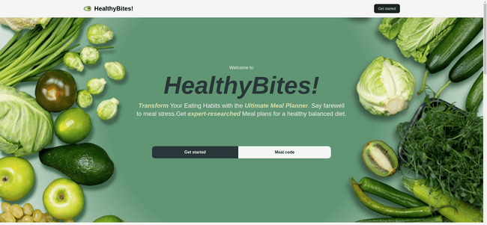

#### 4.2.1.0 Html And tailWind Css Code

<nav

class="bg-myWhite dark:bg-gray-900 fixed w-full z-20 top-0 left-0 border-b border-gray-200 dark:border-gray-600"

>

<div

class="max-w-screen-xl flex flex-wrap items-center justify-between mx-auto p-4"

>

<a href="index.html" class="flex items-center">

<img

src="images/icons/logo160x160.png"

class="h-8 mr-3 animate-spin"

alt="HealthyBites"

/>

<span

class="self-center text-2xl font-semibold whitespace-nowrap dark:text-white"

>HealthyBites!</span

>

</a>

<div class="flex md:order-2">

<a href="code.html">

<button

type="button"

class="text-myWhite bg-myDarkestGreen hover:bg-myGreen focus:ring-4 focus:outline-none focus:ring-myDarkestGreen font-medium rounded-lg text-sm px-4 py-2 text-center mr-3 md:mr-0 dark:bg-blue-600 dark:hover:bg-blue-700 dark:focus:ring-blue-800"

>

Get started

</button>

</a>

</div>

</div>

</nav>

<!--this is the introduction section for thr first screen-->

<header

class="bg-myBgGreen bg-[url('../images/index-mobile-bg.png')] lg:bg-[url('../images/index-desktop-bg.png')] bg-clip-border bg-center bg-cover bg-no-repeat flex flex-col justify-center items-center h-[90svh]"

>

<div>

<p class="font-normal text-sm text-myWhite lg:text-lg text-center">

Welcome to

</p>

<h1

class="text-5xl font-bold italic text-myDarkGreen mt-2 lg:text-8xl text-center"

>

HealthyBites!

</h1>

<p

class="mt-4 text-center text-sm text-center px-6 text-myWhite font-normal lg:text-2xl lg:font-normal lg:w-[55rem]"

>

<em class="text-myEmGreen font-semibold">Transform</em> Your Eating

Habits with the

<em class="text-myEmGreen font-semibold">Ultimate Meal Planner</em>.

Say farewell to meal stress.Get

<em class="text-myEmGreen font-semibold">expert-researched</em> Meal

plans for a healthy balanced diet.

</p>

</div>

<div

class="flex flex-col items-center mt-20 lg:mx-72 lg:flex-row lg:justify-center lg:mt-28"

>

<!--the main btns-->

<a

href="code.html"

id="primary-btn"

class="bg-myDarkGreen rounded-xl lg:rounded-tl-xl lg:rounded-bl-xl lg:rounded-tr-none lg:rounded-br-none font-bold text-center transition ease-in-out delay-150 duration-300 text-myWhite text-xs sm:text-base px-32 sm:px-36 lg:px-32 py-3 lg:ml-32 hover:bg-myEmGreen hover:shadow-xl active:bg-teal-400 focus:bg-myGreen"

>Get started

</a>

<a

id="secondary-btn"

href="specialCode.html"

class="bg-myWhite rounded-xl lg:rounded-tl-none lg:rounded-bl-none lg:rounded-tr-xl lg:rounded-br-xl mt-3 lg:mt-0 font-bold text-center text-xs sm:text-base text-myDarkestGreen px-32 sm:px-36 py-3 lg:mr-32 transition ease-in-out delay-150 duration-300 hover:bg-myEmGreen hover:text-myWhite hover:shadow-xl active:bg-teal-400 active:text-myWhite focus:bg-myGreen"

>Meal code</a

>

</div>

</header>

### 4.2.2 How it Works Section

### 

#### 4.2.2.1 Html And tailWind Css Code

<section

class="flex flex-col flex-nowrap justify-center items-center mb-24"

>

<!--how it works-->

<h2

class="font-poppins italic font-black text-center text-2xl lg:text-6xl text-myDarkestGreen mb-2"

>

How it works

</h2>

<div

class="flex flex-col lg:flex-row lg:p-5 justify-evenly items-center lg:items-start lg:w-[80rem]"

>

<div class="lg:p-2 lg:w-[40rem] mb-3 p-2">

<p class="text-base lg:text-xl mb-4 text-center lg:text-left">

Our system uses a randomization algorithm that generates a 7 day

meal plan ,these meals are balanced and are organized in a way

that they promote a healthy diet while keeping the foods

recommended generally similar to the western and southern african

region.

</p>

<dl class="text-center lg:text-left">

<dt

class="font-bold text-2xl text-myDarkestGreen mb-2 text-center"

>

Steps

</dt>

<dt class="font-semibold">1 start</dt>

<dd class="font-light">

Hit

<em

class="text-myWhite bg-myDarkestGreen hover:bg-myGreen focus:ring-4 focus:outline-none focus:ring-myDarkestGreen font-medium rounded-lg text-sm px-4 py-2 text-center mr-3 md:mr-0 dark:bg-blue-600 dark:hover:bg-blue-700 dark:focus:ring-blue-800"

>get started</em

>to head to detail fill in page

</dd>

<dt class="font-semibold">2 form filling</dt>

<dd class="font-thin">

Fill in your particular detail to generate meal

</dd>

<dt class="font-semibold">3 get meal</dt>

<dd class="font-thin">

Generated meal plan for seven days can be regenerated by

pressing

<em

class="text-myWhite bg-myDarkestGreen hover:bg-myGreen focus:ring-4 focus:outline-none focus:ring-myDarkestGreen font-medium rounded-lg text-sm px-4 py-2 text-center mr-3 md:mr-0 dark:bg-blue-600 dark:hover:bg-blue-700 dark:focus:ring-blue-800"

>Randomize</em

>

</dd>

<dt class="font-semibold">4 Save code</dt>

<dd class="font-thin">

Save

<em

class="text-myWhite bg-myDarkestGreen hover:bg-myGreen focus:ring-4 focus:outline-none focus:ring-myDarkestGreen font-medium rounded-lg text-sm px-4 py-2 text-center mr-3 md:mr-0 dark:bg-blue-600 dark:hover:bg-blue-700 dark:focus:ring-blue-800"

>unique meal name</em

>

and

<em

class="text-myWhite bg-myDarkestGreen hover:bg-myGreen focus:ring-4 focus:outline-none focus:ring-myDarkestGreen font-medium rounded-lg text-sm px-4 py-2 text-center mr-3 md:mr-0 dark:bg-blue-600 dark:hover:bg-blue-700 dark:focus:ring-blue-800"

>meal code</em

>

by writing it down somewhere easy to access

</dd>

</dl>

</div>

<ul

class="lg:p-2 flex flex-row flex-wrap justify-center items-center gap-2 lg:w-[30rem]"

>

<li class="bg-white hover:bg-slate-200 shadow-lg">

<img src="images/icons/sted.png" alt="press-submit" />

</li>

<li class="bg-white hover:bg-myLightOrange shadow-lg">

<img src="images/icons/fms.png" alt="enter-details" />

</li>

<li class="bg-white hover:bg-myDarkOrange shadow-lg">

<img src="images/icons/mls.png" alt="get generated meal" />

</li>

<li class="bg-white hover:bg-myDarkGreen shadow-lg">

<img src="images/icons/mlcd.png" alt="save unique code" />

</li>

</ul>

</div>

</section>

### 4.2.3 Features Section

### 

#### 4.2.3.2 Html And tailWind Css Code

<section class="mb-24">

<!--features-->

<h2

class="font-poppins font-black text-center italic text-2xl lg:text-6xl text-myDarkestGreen mb-2 lg:mb-24"

>

Features

</h2>

<div class="flex flex-row flex-wrap justify-center items-center gap-8">

<div

class="bg-white hover:bg-myDarkGreen hover:text-myWhite shadow-lg rounded p-2"

>

<dl

class="flex flex-col flex-nowrap justify-center items-center w-[300px] h-[500px] p-3"

>

<div>

<img

src="images/icons/price.png"

alt="priceless"

class="pb-4"

/>

</div>

<dt class="font-bold text-lg pb-2 text-center">

No login ,No fees and High security

</dt>

<dd class="text-center">

Our system has no login or subscription which is important to

our users because it provides convenience and simplicity.

Additionally, it offers enhanced security by eliminating the

need to create and manage user accounts, reducing the risk of

personal data breaches.

</dd>

</dl>

</div>

<div

class="bg-white hover:bg-myDarkGreen hover:text-myWhite shadow-lg rounded p-2"

>

<dl

class="flex flex-col flex-nowrap justify-center items-center w-[300px] p-3 h-[500px]"

>

<img

src="images/icons/research.png"

alt="research"

class="pb-4"

/>

<dt class="font-bold text-lg pb-2">Expert research</dt>

<dd class="text-center">

The foundation of this system lies in the expertise and diligent

research conducted by professionals in the field of nutrition.

The meal plans are meticulously crafted, taking into

consideration various factors such as dietary requirements,

health goals, and personal preferences. By relying on this

system, you can trust that your meal plans are backed by solid

scientific knowledge and reliable sources.

</dd>

</dl>

</div>

<div

class="bg-white hover:bg-myDarkGreen hover:text-myWhite shadow-lg rounded p-2"

>

<dl

class="flex flex-col flex-nowrap justify-center items-center w-[300px] p-3 h-[500px]"

>

<img src="images/icons/algo.png" alt="algorithm" class="pb-4" />

<dt class="font-bold text-lg pb-2">Randomization Algorithm</dt>

<dd class="text-center">

Randomization ensures a diverse selection of meals, preventing

monotony and encouraging a well-balanced diet. By generating

varied meal combinations, the algorithm promotes the inclusion

of different food groups, essential nutrients, and a wide range

of vitamins and minerals, resulting in a more comprehensive and

nutritionally balanced meal plan.

</dd>

</dl>

</div>

</div>

</section>

### 4.2.4 Consultation Section

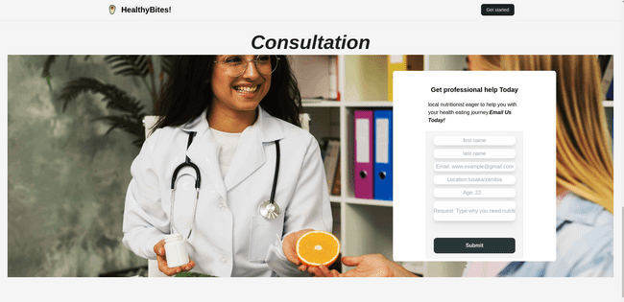

#### 4.2.2.3 Html And tailWind Css Code

<section class="mb-24 w-[100%]">

<h2

class="font-poppins font-black text-center italic text-2xl lg:text-6xl text-myDarkestGreen mb-2"

>

Consultation

</h2>

<!--get a nutritionist help for extra balance-->

<div

class="h-[70svh] bg-[url('../images/bg-nutri.jpg')] bg-clip-border bg-top bg-cover bg-fixed bg-no-repeat flex flex-row flex-wrap justify-center lg:justify-end items-center"

>

<div

class="bg-white rounded-lg p-2 flex flex-col flex-nowrap w-[300px] lg:w-[500px] lg:mr-44 items-center gap-3"

>

<h3 class="text-xl font-bold mt-9">Get professional help Today</h3>

<p class="w-[300px] p-2">

local nutritionist eager to help you with your health eating

journey.<em class="font-bold">Email Us Today!</em>

</p>

<form

action="post"

class="flex flex-col flex-nowrap gap-3 bg-myWhite justify-center items-center rounded w-[300px] p-4"

>

<input

type="text"

name="fname"

id="fname"

placeholder="first name"

class=" w-[250px] h-[28px] rounded-[10px] text-center text-xs sm:text-base drop-shadow-xl transition ease-in-out delay-150 duration-300"

/>

<input

type="text"

id="lname"

name="lname"

placeholder="last name"

class=" w-[250px] h-[28px] rounded-[10px] text-center text-xs sm:text-base drop-shadow-xl transition ease-in-out delay-150 duration-300"

/>

<input

type="email"

name="email"

id="email"

placeholder="Email: www.example@gmail.com"

class=" w-[250px] h-[28px] rounded-[10px] text-center text-xs sm:text-base drop-shadow-xl transition ease-in-out delay-150 duration-300"

/>

<input

type="text"

id="location"

name="location"

placeholder="Location:lusaka/zambia"

class=" w-[250px] h-[28px] rounded-[10px] text-center text-xs sm:text-base drop-shadow-xl transition ease-in-out delay-150 duration-300"

/>

<input

type="number"

name="age"

id="age"

min="1"

max="150"

placeholder="Age: 22"

class=" w-[250px] h-[28px] rounded-[10px] text-center text-xs sm:text-base drop-shadow-xl transition ease-in-out delay-150 duration-300"

/>

<input

type="textfield"

name="reason"

id="reason"

placeholder="Request: Type why you need nutritionist help here ...."

class=" w-[250px] h-[60px] rounded-[10px] text-center text-xs sm:text-base drop-shadow-xl transition ease-in-out delay-150 duration-300"

/>

<input type="Submit" id="Submit-btn" class="bg-myDarkGreen w-[250px] h-[48px] rounded-[10px] text-center text-base font-bold mt-6 lg:mt-10 transition ease-in-out delay-150 duration-300 text-myWhite hover:bg-myEmGreen hover:shadow-xl active:bg-teal-400 focus:bg-myGreen" />

</form>

</div>

</div>

</section>

## 4.3 Details Entry Page (form fill in Page)

This is the page the user views once he or she decides to create a meal plan.its perpose os to get user details such as age ,type of meal needed ,special conditions (diabetic etc) .the purpose of this detail collection is to make sure a meal using the u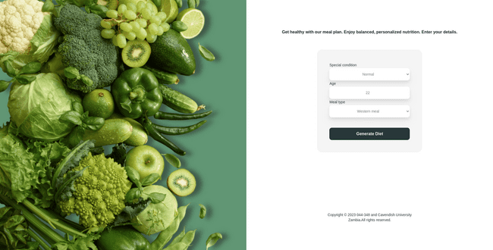sers unique variables is created .

#### 4.3.1 Html And tailWind Css Code

<body

class="bg-myBgGreen bg-[url('../images/code-bg-mobile.png')] lg:bg-[url('../images/code-bg-desktop.png')] bg-no-repeat bg-fixed bg-cover bg-clip-border font-poppins max-h-full flex flex-col lg:flex-row justify-end"

>

<header class="h-[30vh]">

<p id="blank-space"></p>

</header>

<div

id="main-wrap"

class="bg-myWhite lg:bg-white h-[75vh] lg:w-[50vw] lg:h-screen flex flex-col justify-around items-center rounded-tl-3xl rounded-tr-3xl lg:rounded-tl-none lg:rounded-tr-none"

>

<!--thr form wrapped in the main because its the main content-->

<main class="flex flex-col justify-center items-center p-1">

<p class="font-bold text-center text-xs lg:text-base px-7 text-myDarkestGreen">

Get healthy with our meal plan. Enjoy balanced, personalized

nutrition. Enter your details.

</p>

<!--form section-->

<form id="codeSection" class="mt-6 lg:mt-14 lg:bg-myWhite lg:p-12 lg:rounded-[20px]">

<ul>

<!--special condition-->

<li>

<label for="specialNeeds" class="text-sm text-myDarkGreen font-medium"

>Special condition <br /><select

name="spn"

id="specialNeeds"

class="bg-white w-[313px] h-[48px] rounded-[10px] text-center font-light text-myGray drop-shadow-xl"

>

<option value="normal">Normal</option>

<option value="vegan">Vegan</option>

<option value="diabetic">Diabetic</option>

<option value="pescatarian">Pescatarian</option>

</select></label

>

</li>

<li>

<!-- age field-->

<label for="age" class="text-sm text-myDarkGreen font-medium"

>Age <br /><input

type="number"

name="integer"

id="age"

min="1"

max="150"

value="22"

class="bg-white w-[313px] h-[48px] rounded-[10px] text-center font-light text-myGray drop-shadow-xl focus:ring-myGreen"

/></label>

</li>

<!--meal type for people to choose the food resources -->

<li>

<label for="mealType"

class="text-sm text-myDarkGreen font-medium">Meal type <br />

<select name="meal" id="mealType" class="bg-white w-[313px] h-[48px] rounded-[10px] text-center font-light text-myGray drop-shadow-xl focus:ring-myGreen">

<option value="western">Western meal</option>

<option value="zambian">Zambian meal</option>

<option value="mix">Combination meal</option>

</select></label

>

</li>

</ul>

<input type="submit" id="submit-btn" value="Generate Diet" class="bg-myDarkGreen w-[313px] h-[48px] rounded-[10px] text-center text-base font-bold mt-10 transition ease-in-out delay-150 duration-300 text-myWhite hover:bg-myEmGreen hover:shadow-xl active:bg-teal-400 focus:bg-myGreen" />

</form>

</main>

<!--the footer with cavendish details-->

#### 4.3.2 Javascript (logic)

//todo : function to get form details

function getDetails() {

let formDetails = {}; // object to store form data from generation field

//selecting the form fields to retrieve data from

let specialCondition = document.getElementById("specialNeeds");

let age = document.getElementById("age");

let meal = document.getElementById("mealType");

//get the selected value and place it in selected condition

let selectedCondition =

specialCondition.options[specialCondition.selectedIndex].value;

let selectedAge = age.value;

let selectedMealType = meal.options[meal.selectedIndex].value;

// placing them into object formDetails

formDetails.condition = selectedCondition;

formDetails.age = selectedAge;

formDetails.meal = selectedMealType;

return formDetails;

}

//todo :this is the function to stop submit from submitting and perform my function instead

let form = document.getElementById("codeSection");

if (form) {

form.addEventListener("submit", function (event) {

//prevents submit reload

event.preventDefault();

//gets users info to be processed by the meal plan function

let details = getDetails();

// saves the user details to session storage

sessionStorage.setItem("userDetails", JSON.stringify(details));

//loads new page

loadPlanPage();

});

}

## 4.4 Meal page (Randomized meals Page)

This page is the most important page of the web application ,the users details are used to generate a meal plan that is balanced and can be randomized easily again if user wants another meal ,this is the result of a randomization algorythm that help the system create random meals 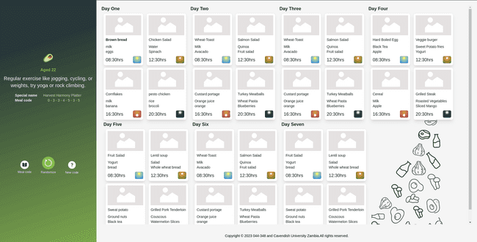using the users information.

#### 4.4.1 Html And tailWind Css Code

<!--this is where the details go for age and recoommentation -->

<header

class="bg-myDarkestGreen lg:bg-[url(../images/bg-meals.png)] bg-cover bg-no-repeat bg-center h-56 w-[100vw] lg:w-[40rem] lg:h-[100svh] flex flex-col justify-self-start lg:justify-around rounded-b-3xl lg:rounded-none sticky lg:relative p-1 lg:p-3 lg:overflow-hidden"

>

<div id="wrapper-dets" class="flex flex-col justify-center items-center">

<!--this is banner for the logo-->

<div id="logo-wrapper" class="justify-self-center self-center">

<a href="index.html">

<img

src="images/icons/logo160x160.png"

alt="HealthyBites!"

class="w-12 h-12 mt-4 lg:mt-28 animate-spin"

/></a>

</div>

<!--here is where the special code for people to get and enter on -->

<div id="loadage" class="self-center justify-self-center">

<h1

id="Header-Age"

class="text-center mt-3 font-extrabold text-base text-myGreen mb-2"

>

Recommendation

</h1>

<p class="text-center font-light text-myWhite text-sm lg:text-xl">

Remember, eating healthy can be as easy as adding some colorful veggies to your plate.

</p>

</div>

<!-- special details wrapper-->

<div

id="special-detail-wrapper"

class="self-center mt-3 justify-self-center lg:mt-4"

>

<div id="special-name-wrapper" class="flex flex-row">

<h2 class="font-bold text-myWhite mr-3 lg:text-sm">Special name</h2>

<p id="special-name" class="text-myEmGreen ml-3 lg:text-sm">

SPECIAL NAME HERE

</p>

</div>

<div id="special-code-wrapper" class="flex flex-row">

<h2 class="font-bold text-myWhite mr-4 lg:text-sm">Meal code</h2>

<p id="special-code" class="text-myEmGreen ml-12 lg:text-sm">

XXXXXXX

</p>

</div>

</div>

</div>

<!--this is for buttons that will be used for basic navigation-->

<ul

id="randomizer"

class="fixed lg:relative bottom-0 lg:mt-14 self-center justify-self-center flex flex-row justify-evenly items-center bg-myDarkestGreen lg:bg-transparent w-[100vw] lg:w-[20rem]"

>

<li>

<a href="specialCode.html" class="flex flex-col justify-center items-center"

><img

src="images/icons/recipes.png"

alt="Recipes"

class="active:animate-spin hover:animate-pulse"

/>

<p

class="text-myWhite text-xs pt-1 hover:animate-pulse hover:text-myGreen"

>

Meal code

</p></a

>

</li>

<li id="random-btn">

<button

class="flex flex-col justify-center items-center relative bottom-2"

>

<img

src="images/icons/randomize.png"

alt="Randomise"

class="active:animate-spin hover:animate-pulse"

/>

<p

class="hover:animate-pulse hover:text-myGreen text-myWhite text-xs pt-1"

>

Randomize

</p>

</button>

</li>

<li>

<a href="code.html" class="flex flex-col justify-center items-center"

><img

src="images/icons/guide.png"

alt="Guide"

class="active:animate-spin hover:animate-pulse"

/>

<p

class="text-myWhite text-xs pt-1 hover:animate-pulse hover:text-myGreen"

>

New code

</p>

</a>

</li>

</ul>

<!-- this is where it displays if you -->

<div id="msg-section"></div>

</header>

<!--div to hold main and footer-->

<div

class="flex flex-col mb-20 lg:mb-0 p-2 lg:p-5 lg:h-[100svh] justify-evenly items-center"

>

<main

id="sevenday-plan"

class="flex flex-row flex-wrap mb-5 justify-center lg:justify-start space-x-2 items-center lg:items-stretch lg:overflow-y-scroll lg:bg-[url(../images/meal-Desktop-bg.png)] bg-fixed bg-no-repeat bg-cover![alt text](image_url)"

>

<!--first day card-->

<div id="day1" class="w-[350px]">

<h3 class="text-myDarkestGreen font-bold text-lg">Day One</h3>

<div

class="day-card flex flex-row flex-wrap justify-evenly items-center"

>

<!--morning card-->

<div

class="breakfast p-2 m-1 border hover:border-myDarkestGreen rounded-lg bg-white hover:bg-slate-200 shadow-lg"

>

<img src="images/icons/placehold.png" alt="morning meal" />

<dl class="mt-2 mb-2">

<dt class="text-myDarkestGreen font-bold text-sm">

meal name

</dt>

<dd class="mt-2 text-myDarkestGreen text-sm font-light">

bavarage

</dd>

<dd class="text-myDarkestGreen text-sm font-light">

side dish

</dd>

</dl>

<div class="flex flex-row justify-between items-center">

<time

datetime="T08:30"

class="text-myDarkestGreen font-medium text-lg"

>08:30hrs</time

><img src="images/icons/morning.png" alt="08:30hrs" />

</div>

</div>

<!--day card-->

<div

class="lunch p-2 m-1 border hover:border-myDarkestGreen rounded-lg bg-white hover:bg-myLightOrange shadow-lg"

>

<img src="images/icons/placehold.png" alt="lunch" />

<dl class="mt-2 mb-2">

<dt class="text-myDarkestGreen font-medium text-sm">

meal name

</dt>

<dd class="mt-2 text-myDarkestGreen text-sm font-light">

bavarage

</dd>

<dd class="text-myDarkestGreen text-sm font-light">

side dish

</dd>

</dl>

<div class="flex flex-row justify-between items-center">

<time

datetime="T12:30"

class="text-myDarkestGreen font-medium text-lg"

>12:30hrs</time

><img src="images/icons/afternoon.png" alt="12:30hrs" />

</div>

</div>

<!--sunset card-->

<div

class="snack p-2 m-1 border hover:border-myDarkestGreen rounded-lg bg-white hover:bg-myDarkOrange shadow-lg"

>

<img src="images/icons/placehold.png" alt="snack" />

<dl class="mt-2 mb-2">

<dt class="text-myDarkestGreen font-medium text-sm">

meal name

</dt>

<dd class="mt-2 text-myDarkestGreen text-sm font-light">

bavarage

</dd>

<dd class="text-myDarkestGreen text-sm font-light">

side dish

</dd>

</dl>

<div class="flex flex-row justify-between items-center">

<time

datetime="T16:30"

class="text-myDarkestGreen font-medium text-lg"

>16:30hrs</time

><img src="images/icons/sunset.png" alt="16:30hrs" />

</div>

</div>

<!--night card-->

<div

class="supa p-2 m-1 border hover:border-myDarkestGreen rounded-lg bg-white hover:bg-slate-600 shadow-lg"

>

<img src="images/icons/placehold.png" alt="snack" />

<dl class="mt-2 mb-2">

<dt class="text-myDarkestGreen font-medium text-sm">

meal name

</dt>

<dd class="mt-2 text-myDarkestGreen text-sm font-light">

bavarage

</dd>

<dd class="text-myDarkestGreen text-sm font-light">

side dish

</dd>

</dl>

<div class="flex flex-row justify-between items-center">

<time

datetime="T20:30"

class="text-myDarkestGreen font-medium text-lg"

>20:30hrs</time

><img src="images/icons/night.png" alt="20:30hrs" />

</div>

</div>

</div>

</div>

<!--second day card-->

<div id="day2" class="w-[350px]">

<h3 class="text-myDarkestGreen font-bold text-lg">Day Two</h3>

<div

class="day-card flex flex-row flex-wrap justify-evenly items-center"

>

<!--morning card-->

<div

class="breakfast p-2 m-1 border hover:border-myDarkestGreen rounded-lg bg-white hover:bg-slate-200 shadow-lg"

>

<img src="images/icons/placehold.png" alt="morning meal" />

<dl class="mt-2 mb-2">

<dt class="text-myDarkestGreen font-medium text-sm">

meal name

</dt>

<dd class="mt-2 text-myDarkestGreen text-sm font-light">

bavarage

</dd>

<dd class="text-myDarkestGreen text-sm font-light">

side dish

</dd>

</dl>

<div class="flex flex-row justify-between items-center">

<time

datetime="T08:30"

class="text-myDarkestGreen font-medium text-lg"

>08:30hrs</time

><img src="images/icons/morning.png" alt="08:30hrs" />

</div>

</div>

<!--day card-->

<div

class="lunch p-2 m-1 border hover:border-myDarkestGreen rounded-lg bg-white hover:bg-myLightOrange shadow-lg"

>

<img src="images/icons/placehold.png" alt="lunch" />

<dl class="mt-2 mb-2">

<dt class="text-myDarkestGreen font-medium text-sm">

meal name

</dt>

<dd class="mt-2 text-myDarkestGreen text-sm font-light">

bavarage

</dd>

<dd class="text-myDarkestGreen text-sm font-light">

side dish

</dd>

</dl>

<div class="flex flex-row justify-between items-center">

<time

datetime="T12:30"

class="text-myDarkestGreen font-medium text-lg"

>12:30hrs</time

><img src="images/icons/afternoon.png" alt="12:30hrs" />

</div>

</div>

<!--sunset card-->

<div

class="snack p-2 m-1 border hover:border-myDarkestGreen rounded-lg bg-white hover:bg-myDarkOrange shadow-lg"

>

<img src="images/icons/placehold.png" alt="snack" />

<dl class="mt-2 mb-2">

<dt class="text-myDarkestGreen font-medium text-sm">

meal name

</dt>

<dd class="mt-2 text-myDarkestGreen text-sm font-light">

bavarage

</dd>

<dd class="text-myDarkestGreen text-sm font-light">

side dish

</dd>

</dl>

<div class="flex flex-row justify-between items-center">

<time

datetime="T16:30"

class="text-myDarkestGreen font-medium text-lg"

>16:30hrs</time

><img src="images/icons/sunset.png" alt="16:30hrs" />

</div>

</div>

<!--night card-->

<div

class="supa p-2 m-1 border hover:border-myDarkestGreen rounded-lg bg-white hover:bg-slate-600 shadow-lg"

>

<img src="images/icons/placehold.png" alt="snack" />

<dl class="mt-2 mb-2">

<dt class="text-myDarkestGreen font-medium text-sm">

meal name

</dt>

<dd class="mt-2 text-myDarkestGreen text-sm font-light">

bavarage

</dd>

<dd class="text-myDarkestGreen text-sm font-light">

side dish

</dd>

</dl>

<div class="flex flex-row justify-between items-center">

<time

datetime="T20:30"

class="text-myDarkestGreen font-medium text-lg"

>20:30hrs</time

><img src="images/icons/night.png" alt="20:30hrs" />

</div>

</div>

</div>

</div>

<!--third day card-->

<div id="day3" class="w-[350px]">

<h3 class="text-myDarkestGreen font-bold text-lg">Day Three</h3>

<div

class="day-card flex flex-row flex-wrap justify-evenly items-center"

>

<!--morning card-->

<div

class="breakfast p-2 m-1 border hover:border-myDarkestGreen rounded-lg bg-white hover:bg-slate-200 shadow-lg"

>

<img src="images/icons/placehold.png" alt="morning meal" />

<dl class="mt-2 mb-2">

<dt class="text-myDarkestGreen font-medium text-sm">

meal name

</dt>

<dd class="mt-2 text-myDarkestGreen text-sm font-light">

bavarage

</dd>

<dd class="text-myDarkestGreen text-sm font-light">

side dish

</dd>

</dl>

<div class="flex flex-row justify-between items-center">

<time

datetime="T08:30"

class="text-myDarkestGreen font-medium text-lg"

>08:30hrs</time

><img src="images/icons/morning.png" alt="08:30hrs" />

</div>

</div>

<!--day card-->

<div

class="lunch p-2 m-1 border hover:border-myDarkestGreen rounded-lg bg-white hover:bg-myLightOrange shadow-lg"

>

<img src="images/icons/placehold.png" alt="lunch" />

<dl class="mt-2 mb-2">

<dt class="text-myDarkestGreen font-medium text-sm">

meal name

</dt>

<dd class="mt-2 text-myDarkestGreen text-sm font-light">

bavarage

</dd>

<dd class="text-myDarkestGreen text-sm font-light">

side dish

</dd>

</dl>

<div class="flex flex-row justify-between items-center">

<time

datetime="T12:30"

class="text-myDarkestGreen font-medium text-lg"

>12:30hrs</time

><img src="images/icons/afternoon.png" alt="12:30hrs" />

</div>

</div>

<!--sunset card-->

<div

class="snack p-2 m-1 border hover:border-myDarkestGreen rounded-lg bg-white hover:bg-myDarkOrange shadow-lg"

>

<img src="images/icons/placehold.png" alt="snack" />

<dl class="mt-2 mb-2">

<dt class="text-myDarkestGreen font-medium text-sm">

meal name

</dt>

<dd class="mt-2 text-myDarkestGreen text-sm font-light">

bavarage

</dd>

<dd class="text-myDarkestGreen text-sm font-light">

side dish

</dd>

</dl>

<div class="flex flex-row justify-between items-center">

<time

datetime="T16:30"

class="text-myDarkestGreen font-medium text-lg"

>16:30hrs</time

><img src="images/icons/sunset.png" alt="16:30hrs" />

</div>

</div>

<!--night card-->

<div

class="supa p-2 m-1 border hover:border-myDarkestGreen rounded-lg bg-white hover:bg-slate-600 shadow-lg"

>

<img src="images/icons/placehold.png" alt="snack" />

<dl class="mt-2 mb-2">

<dt class="text-myDarkestGreen font-medium text-sm">

meal name

</dt>

<dd class="mt-2 text-myDarkestGreen text-sm font-light">

bavarage

</dd>

<dd class="text-myDarkestGreen text-sm font-light">

side dish

</dd>

</dl>

<div class="flex flex-row justify-between items-center">

<time

datetime="T20:30"

class="text-myDarkestGreen font-medium text-lg"

>20:30hrs</time

><img src="images/icons/night.png" alt="20:30hrs" />

</div>

</div>

</div>

</div>

<!--fourth day card-->

<div id="day4" class="w-[350px]">

<h3 class="text-myDarkestGreen font-bold text-lg">Day Four</h3>

<div

class="day-card flex flex-row flex-wrap justify-evenly items-center"

>

<!--morning card-->

<div

class="breakfast p-2 m-1 border hover:border-myDarkestGreen rounded-lg bg-white hover:bg-slate-200 shadow-lg"

>

<img src="images/icons/placehold.png" alt="morning meal" />

<dl class="mt-2 mb-2">

<dt class="text-myDarkestGreen font-medium text-sm">

meal name

</dt>

<dd class="mt-2 text-myDarkestGreen text-sm font-light">

bavarage

</dd>

<dd class="text-myDarkestGreen text-sm font-light">

side dish

</dd>

</dl>

<div class="flex flex-row justify-between items-center">

<time

datetime="T08:30"

class="text-myDarkestGreen font-medium text-lg"

>08:30hrs</time

><img src="images/icons/morning.png" alt="08:30hrs" />

</div>

</div>

<!--day card-->

<div

class="lunch p-2 m-1 border hover:border-myDarkestGreen rounded-lg bg-white hover:bg-myLightOrange shadow-lg"

>

<img src="images/icons/placehold.png" alt="lunch" />

<dl class="mt-2 mb-2">

<dt class="text-myDarkestGreen font-medium text-sm">

meal name

</dt>

<dd class="mt-2 text-myDarkestGreen text-sm font-light">

bavarage

</dd>

<dd class="text-myDarkestGreen text-sm font-light">

side dish

</dd>

</dl>

<div class="flex flex-row justify-between items-center">

<time

datetime="T12:30"

class="text-myDarkestGreen font-medium text-lg"

>12:30hrs</time

><img src="images/icons/afternoon.png" alt="12:30hrs" />

</div>

</div>

<!--sunset card-->

<div

class="snack p-2 m-1 border hover:border-myDarkestGreen rounded-lg bg-white hover:bg-myDarkOrange shadow-lg"

>

<img src="images/icons/placehold.png" alt="snack" />

<dl class="mt-2 mb-2">

<dt class="text-myDarkestGreen font-medium text-sm">

meal name

</dt>

<dd class="mt-2 text-myDarkestGreen text-sm font-light">

bavarage

</dd>

<dd class="text-myDarkestGreen text-sm font-light">

side dish

</dd>

</dl>

<div class="flex flex-row justify-between items-center">

<time

datetime="T16:30"

class="text-myDarkestGreen font-medium text-lg"

>16:30hrs</time

><img src="images/icons/sunset.png" alt="16:30hrs" />

</div>

</div>

<!--night card-->

<div

class="supa p-2 m-1 border hover:border-myDarkestGreen rounded-lg bg-white hover:bg-slate-600 shadow-lg"

>

<img src="images/icons/placehold.png" alt="snack" />

<dl class="mt-2 mb-2">

<dt class="text-myDarkestGreen font-medium text-sm">

meal name

</dt>

<dd class="mt-2 text-myDarkestGreen text-sm font-light">

bavarage

</dd>

<dd class="text-myDarkestGreen text-sm font-light">

side dish

</dd>

</dl>

<div class="flex flex-row justify-between items-center">

<time

datetime="T20:30"

class="text-myDarkestGreen font-medium text-lg"

>20:30hrs</time

><img src="images/icons/night.png" alt="20:30hrs" />

</div>

</div>

</div>

</div>

<!-- Fifth day card-->

<div id="day5" class="w-[350px]">

<h3 class="text-myDarkestGreen font-bold text-lg">Day Five</h3>

<div

class="day-card flex flex-row flex-wrap justify-evenly items-center"

>

<!--morning card-->

<div

class="breakfast p-2 m-1 border hover:border-myDarkestGreen rounded-lg bg-white hover:bg-slate-200 shadow-lg"

>

<img src="images/icons/placehold.png" alt="morning meal" />

<dl class="mt-2 mb-2">

<dt class="text-myDarkestGreen font-medium text-sm">

meal name

</dt>

<dd class="mt-2 text-myDarkestGreen text-sm font-light">

bavarage

</dd>

<dd class="text-myDarkestGreen text-sm font-light">

side dish

</dd>

</dl>

<div class="flex flex-row justify-between items-center">

<time

datetime="T08:30"

class="text-myDarkestGreen font-medium text-lg"

>08:30hrs</time

><img src="images/icons/morning.png" alt="08:30hrs" />

</div>

</div>

<!--day card-->

<div

class="lunch p-2 m-1 border hover:border-myDarkestGreen rounded-lg bg-white hover:bg-myLightOrange shadow-lg"

>

<img src="images/icons/placehold.png" alt="lunch" />

<dl class="mt-2 mb-2">

<dt class="text-myDarkestGreen font-medium text-sm">

meal name

</dt>

<dd class="mt-2 text-myDarkestGreen text-sm font-light">

bavarage

</dd>

<dd class="text-myDarkestGreen text-sm font-light">

side dish

</dd>

</dl>

<div class="flex flex-row justify-between items-center">

<time

datetime="T12:30"

class="text-myDarkestGreen font-medium text-lg"

>12:30hrs</time

><img src="images/icons/afternoon.png" alt="12:30hrs" />

</div>

</div>

<!--sunset card-->

<div

class="snack p-2 m-1 border hover:border-myDarkestGreen rounded-lg bg-white hover:bg-myDarkOrange shadow-lg"

>

<img src="images/icons/placehold.png" alt="snack" />

<dl class="mt-2 mb-2">

<dt class="text-myDarkestGreen font-medium text-sm">

meal name

</dt>

<dd class="mt-2 text-myDarkestGreen text-sm font-light">

bavarage

</dd>

<dd class="text-myDarkestGreen text-sm font-light">

side dish

</dd>

</dl>

<div class="flex flex-row justify-between items-center">

<time

datetime="T16:30"

class="text-myDarkestGreen font-medium text-lg"

>16:30hrs</time

><img src="images/icons/sunset.png" alt="16:30hrs" />

</div>

</div>

<!--night card-->

<div

class="supa p-2 m-1 border hover:border-myDarkestGreen rounded-lg bg-white hover:bg-slate-600 shadow-lg"

>

<img src="images/icons/placehold.png" alt="snack" />

<dl class="mt-2 mb-2">

<dt class="text-myDarkestGreen font-medium text-sm">

meal name

</dt>

<dd class="mt-2 text-myDarkestGreen text-sm font-light">

bavarage

</dd>

<dd class="text-myDarkestGreen text-sm font-light">

side dish

</dd>

</dl>

<div class="flex flex-row justify-between items-center">

<time

datetime="T20:30"

class="text-myDarkestGreen font-medium text-lg"

>20:30hrs</time

><img src="images/icons/night.png" alt="20:30hrs" />

</div>

</div>

</div>

</div>

<!-- SIxth Day Card-->

<div id="day6" class="w-[350px]">

<h3 class="text-myDarkestGreen font-bold text-lg">Day Six</h3>

<div

class="day-card flex flex-row flex-wrap justify-evenly items-center"

>

<!--morning card-->

<div

class="breakfast p-2 m-1 border hover:border-myDarkestGreen rounded-lg bg-white hover:bg-slate-200 shadow-lg"

>

<img src="images/icons/placehold.png" alt="morning meal" />

<dl class="mt-2 mb-2">

<dt class="text-myDarkestGreen font-medium text-sm">

meal name

</dt>

<dd class="mt-2 text-myDarkestGreen text-sm font-light">

bavarage

</dd>

<dd class="text-myDarkestGreen text-sm font-light">

side dish

</dd>

</dl>

<div class="flex flex-row justify-between items-center">

<time

datetime="T08:30"

class="text-myDarkestGreen font-medium text-lg"

>08:30hrs</time

><img src="images/icons/morning.png" alt="08:30hrs" />

</div>

</div>

<!--day card-->

<div

class="lunch p-2 m-1 border hover:border-myDarkestGreen rounded-lg bg-white hover:bg-myLightOrange shadow-lg"

>

<img src="images/icons/placehold.png" alt="lunch" />

<dl class="mt-2 mb-2">

<dt class="text-myDarkestGreen font-medium text-sm">

meal name

</dt>

<dd class="mt-2 text-myDarkestGreen text-sm font-light">

bavarage

</dd>

<dd class="text-myDarkestGreen text-sm font-light">

side dish

</dd>

</dl>

<div class="flex flex-row justify-between items-center">

<time

datetime="T12:30"

class="text-myDarkestGreen font-medium text-lg"

>12:30hrs</time

><img src="images/icons/afternoon.png" alt="12:30hrs" />

</div>

</div>

<!--sunset card-->

<div

class="snack p-2 m-1 border hover:border-myDarkestGreen rounded-lg bg-white hover:bg-myDarkOrange shadow-lg"

>

<img src="images/icons/placehold.png" alt="snack" />

<dl class="mt-2 mb-2">

<dt class="text-myDarkestGreen font-medium text-sm">

meal name

</dt>

<dd class="mt-2 text-myDarkestGreen text-sm font-light">

bavarage

</dd>

<dd class="text-myDarkestGreen text-sm font-light">

side dish

</dd>

</dl>

<div class="flex flex-row justify-between items-center">

<time

datetime="T16:30"

class="text-myDarkestGreen font-medium text-lg"

>16:30hrs</time

><img src="images/icons/sunset.png" alt="16:30hrs" />

</div>

</div>

<!--night card-->

<div

class="supa p-2 m-1 border hover:border-myDarkestGreen rounded-lg bg-white hover:bg-slate-600 shadow-lg"

>

<img src="images/icons/placehold.png" alt="snack" />

<dl class="mt-2 mb-2">

<dt class="text-myDarkestGreen font-medium text-sm">

meal name

</dt>

<dd class="mt-2 text-myDarkestGreen text-sm font-light">

bavarage

</dd>

<dd class="text-myDarkestGreen text-sm font-light">

side dish

</dd>

</dl>

<div class="flex flex-row justify-between items-center">

<time

datetime="T20:30"

class="text-myDarkestGreen font-medium text-lg"

>20:30hrs</time

><img src="images/icons/night.png" alt="20:30hrs" />

</div>

</div>

</div>

</div>

<!-- Seventh day card-->

<div id="day7" class="w-[350px]">

<h3 class="text-myDarkestGreen font-bold text-lg">Day Seven</h3>

<div

class="day-card flex flex-row flex-wrap justify-evenly items-center"

>

<!--morning card-->

<div

class="breakfast p-2 m-1 border hover:border-myDarkestGreen rounded-lg bg-white hover:bg-slate-200 shadow-lg"

>

<img src="images/icons/placehold.png" alt="morning meal" />

<dl class="mt-2 mb-2">

<dt class="text-myDarkestGreen font-medium text-sm">

meal name

</dt>

<dd class="mt-2 text-myDarkestGreen text-sm font-light">

bavarage

</dd>

<dd class="text-myDarkestGreen text-sm font-light">

side dish

</dd>

</dl>

<div class="flex flex-row justify-between items-center">

<time

datetime="T08:30"

class="text-myDarkestGreen font-medium text-lg"

>08:30hrs</time

><img src="images/icons/morning.png" alt="08:30hrs" />

</div>

</div>

<!--day card-->

<div

class="lunch p-2 m-1 border hover:border-myDarkestGreen rounded-lg bg-white hover:bg-myLightOrange shadow-lg"

>

<img src="images/icons/placehold.png" alt="lunch" />

<dl class="mt-2 mb-2">

<dt class="text-myDarkestGreen font-medium text-sm">

meal name

</dt>

<dd class="mt-2 text-myDarkestGreen text-sm font-light">

bavarage

</dd>

<dd class="text-myDarkestGreen text-sm font-light">

side dish

</dd>

</dl>

<div class="flex flex-row justify-between items-center">

<time

datetime="T12:30"

class="text-myDarkestGreen font-medium text-lg"

>12:30hrs</time

><img src="images/icons/afternoon.png" alt="12:30hrs" />

</div>

</div>

<!--sunset card-->

<div

class="snack p-2 m-1 border hover:border-myDarkestGreen rounded-lg bg-white hover:bg-myDarkOrange shadow-lg"

>

<img src="images/icons/placehold.png" alt="snack" />

<dl class="mt-2 mb-2">

<dt class="text-myDarkestGreen font-medium text-sm">

meal name

</dt>

<dd class="mt-2 text-myDarkestGreen text-sm font-light">

bavarage

</dd>

<dd class="text-myDarkestGreen text-sm font-light">

side dish

</dd>

</dl>

<div class="flex flex-row justify-between items-center">

<time

datetime="T16:30"

class="text-myDarkestGreen font-medium text-lg"

>16:30hrs</time

><img src="images/icons/sunset.png" alt="16:30hrs" />

</div>

</div>

<!--night card-->

<div

class="supa p-2 m-1 border hover:border-myDarkestGreen rounded-lg bg-white hover:bg-slate-600 shadow-lg"

>

<img src="images/icons/placehold.png" alt="snack" />

<dl class="mt-2 mb-2">

<dt class="text-myDarkestGreen font-medium text-sm">

meal name

</dt>

<dd class="mt-2 text-myDarkestGreen text-sm font-light">

bavarage

</dd>

<dd class="text-myDarkestGreen text-sm font-light">

side dish

</dd>

</dl>

<div class="flex flex-row justify-between items-center">

<time

datetime="T20:30"

class="text-myDarkestGreen font-medium text-lg"

>20:30hrs</time

><img src="images/icons/night.png" alt="20:30hrs" />

</div>

</div>

</div>

</div>

</main>

#### 4.4.2 Javascript (logic)

//todo :normal meals

let normalized = [

//day1

{

image: "images/meals/normal",

breakfast: "vitumbuwa",

breakfastSide: ["milk", "Eggs"],

lunch: "nshima",

lunchside: ["Village chicken", "Spinach"],

mealSunset: "Fried sweet potatoes ",

mealSunsetSide: ["Black tea", "Ground nuts"],

eveningmeal: "nshima",

eveningmealside: ["Village Chicken", "Beans"],

},

//day2

{

image: "images/meals/normal",

breakfast: "Peanut butter Buns",

breakfastSide: ["Milk tea", "Banana"],

lunch: "nshima",

lunchside: ["Salted Fish", "Kalembula veg"],

mealSunset: "Brown bread",

mealSunsetSide: ["Lemon juice", "oranges"],

eveningmeal: "nshima",

eveningmealside: ["Salted fish", "Beans"],

},

//day3

{

image: "images/meals/normal",

breakfast: "2 slices bread",

breakfastSide: ["milk", "eggs"],

lunch: "nshima",

lunchside: ["vinkubala", "cabbage"],

mealSunset: "Fried Casava",

mealSunsetSide: ["Black tea", "Ground nuts"],

eveningmeal: "nshima",

eveningmealside: ["Vinkubala", "Casava leaves"],

},

//day4

{

images: "images/meals/normal",

breakfast: "Sample (corn mix)",

breakfastSide: ["Tea", "orange"],

lunch: "nshima",

lunchside: ["Kapenta", "Five years(veggies)"],

mealSunset: "Tobwa",

mealSunsetSide: ["Water", "Mangoes"],

eveningmeal: "Rice",

eveningmealside: ["kapenta", "Green beans"],

},

//day5

{

image: "images/meals/normal",

breakfast: "Portage",

breakfastSide: ["Milk", "Banana"],

lunch: "nshima",

lunchside: ["Dry fish", "spinach"],

mealSunset: "Wild fruits",

mealSunsetSide: ["Orange juice", "banana"],

eveningmeal: "nshima",

eveningmealside: ["Dry fish", "Kalembla"],

},

//day6

{

image: "images/meals/normal",

breakfast: "Chapati",

breakfastSide: ["milk", "eggs"],

lunch: "nshima",

lunchside: ["Boiled fish", "spinach"],

mealSunset: "Jam Bun",

mealSunsetSide: ["Lemon juice", "orange"],

eveningmeal: "nshima",

eveningmealside: ["Boiled fish", "Beans"],

},

//day7

{

images: "images/meals/normal",

breakfast: "brown bread",

breakfastSide: ["milk", "eggs"],

lunch: "nshima",

lunchside: ["Goat meat", "rep veggies"],

mealSunset: "Portage",

mealSunsetSide: ["Tea", "Mangoes"],

eveningmeal: "Fried Rice",

eveningmealside: ["Goat meat", "spinach"],

},

];

let normalWest = [

//day1

{

breakfast: "Brown bread",

breakfastSide: ["milk", "eggs"],

lunch: "Chicken Salad",

lunchside: ["Water", "Spinach"],

mealSunset: "Cornflakes",

mealSunsetSide: ["milk", "banana"],

eveningmeal: "pesto chicken",

eveningmealside: ["rice", "brocoli"],

},

//day2

{

breakfast: "Oat meal",

breakfastSide: ["Nuts", "Banana"],

lunch: "Quinoa",

lunchside: ["Chickpea", "Orange juice"],

mealSunset: "Brown bread",

mealSunsetSide: ["Black Tea", "Apple"],

eveningmeal: "Chickpea Curry",

eveningmealside: ["Sausage", "pear"],

},

//day3

{

breakfast: "Yogurt parfait",

breakfastSide: ["Barries", "Granola"],

lunch: "Grilled Chicken",

lunchside: ["Roasted Veg", "Pasta"],

mealSunset: "Black bean soup",

mealSunsetSide: ["salad", "bread"],

eveningmeal: "Grilled Chicken Breast",

eveningmealside: ["Steamed Broccoli", "Sliced Strawberries"],

},

//day4

{

breakfast: "Wheat-Toast",

breakfastSide: ["Milk", "Avacado"],

lunch: "Salmon Salad",

lunchside: ["Quinoa", "Fruit salad"],

mealSunset: "Custard portage",

mealSunsetSide: ["Orange juice", "orange"],

eveningmeal: "Turkey Meatballs",

eveningmealside: ["Wheat Pasta", "Blueberries"],

},

//day5

{

breakfast: "Hard Boiled Egg",

breakfastSide: ["Black Tea", "Apple"],

lunch: "Veggie burger",

lunchside: ["Sweet Potato fries", "Yogurt"],

mealSunset: "Cereal",

mealSunsetSide: ["Milk", "Apple"],

eveningmeal: "Grilled Steak",

eveningmealside: ["Roasted Vegetables", "Sliced Mango"],

},

//day6

{

breakfast: "Fruit Salad",

breakfastSide: ["Yogurt", "bread"],

lunch: "Lentil soup",

lunchside: ["Salad", "Whole wheat bread"],

mealSunset: "Sweat potato",

mealSunsetSide: ["Ground nuts", "Black tea"],

eveningmeal: "Grilled Pork Tenderloin",

eveningmealside: ["Couscous", "Watermelon Slices"],

},

//day7

{

breakfast: "Cereal",

breakfastSide: ["milk", "egg"],

lunch: "Chicken stir-fry",

lunchside: ["Brown rice", "Edamame"],

mealSunset: "Oat meal",

mealSunsetSide: ["Milk", "Banana"],

eveningmeal: "Baked Cod",

eveningmealside: ["Quinoa Pilaf", "Kiwi Slices"],

},

];

let normalMix = [

//day1

{

image: "images/meals/normal",

breakfast: "vitumbuwa",

breakfastSide: ["milk", "Eggs"],

lunch: "nshima",

lunchside: ["Village chicken", "Spinach"],

mealSunset: "Fried sweet potatoes ",

mealSunsetSide: ["Black tea", "Ground nuts"],

eveningmeal: "nshima",

eveningmealside: ["Village Chicken", "Beans"],

},

//day2

{

image: "images/meals/normal",

breakfast: "Peanut butter Buns",

breakfastSide: ["Milk tea", "Banana"],

lunch: "nshima",

lunchside: ["Salted Fish", "Kalembula veg"],

mealSunset: "Brown bread",

mealSunsetSide: ["Lemon juice", "oranges"],

eveningmeal: "nshima",

eveningmealside: ["Salted fish", "Beans"],

},

//day3

{

image: "images/meals/normal",

breakfast: "2 slices bread",

breakfastSide: ["milk", "eggs"],

lunch: "nshima",

lunchside: ["vinkubala", "cabbage"],

mealSunset: "Fried Casava",

mealSunsetSide: ["Black tea", "Ground nuts"],

eveningmeal: "nshima",

eveningmealside: ["Vinkubala", "Casava leaves"],

},

//day4

{

images: "images/meals/normal",

breakfast: "Sample (corn mix)",

breakfastSide: ["Tea", "orange"],

lunch: "nshima",

lunchside: ["Kapenta", "Five years(veggies)"],

mealSunset: "Tobwa",

mealSunsetSide: ["Water", "Mangoes"],

eveningmeal: "Rice",

eveningmealside: ["kapenta", "Green beans"],

},

//day5

{

image: "images/meals/normal",

breakfast: "Portage",

breakfastSide: ["Milk", "Banana"],

lunch: "nshima",

lunchside: ["Dry fish", "spinach"],

mealSunset: "Wild fruits",

mealSunsetSide: ["Orange juice", "banana"],

eveningmeal: "nshima",

eveningmealside: ["Dry fish", "Kalembla"],

},

//day6

{

image: "images/meals/normal",

breakfast: "Chapati",

breakfastSide: ["milk", "eggs"],

lunch: "nshima",

lunchside: ["Boiled fish", "spinach"],

mealSunset: "Jam Bun",

mealSunsetSide: ["Lemon juice", "orange"],

eveningmeal: "nshima",

eveningmealside: ["Boiled fish", "Beans"],

},

//day7

{

images: "images/meals/normal",

breakfast: "brown bread",

breakfastSide: ["milk", "eggs"],

lunch: "nshima",

lunchside: ["Goat meat", "rep veggies"],

mealSunset: "Portage",

mealSunsetSide: ["Tea", "Mangoes"],

eveningmeal: "Fried Rice",

eveningmealside: ["Goat meat", "spinach"],

},

//day8

{

breakfast: "Brown bread",

breakfastSide: ["milk", "eggs"],

lunch: "Chicken Salad",

lunchside: ["Water", "Spinach"],

mealSunset: "Cornflakes",

mealSunsetSide: ["milk", "banana"],

eveningmeal: "pesto chicken",

eveningmealside: ["rice", "brocoli"],

},

//day9

{

breakfast: "Oat meal",

breakfastSide: ["Nuts", "Banana"],

lunch: "Quinoa",

lunchside: ["Chickpea", "Orange juice"],

mealSunset: "Brown bread",

mealSunsetSide: ["Black Tea", "Apple"],

eveningmeal: "Chickpea Curry",

eveningmealside: ["Sausage", "pear"],

},

//day10

{

breakfast: "Yogurt parfait",

breakfastSide: ["Barries", "Granola"],

lunch: "Grilled Chicken",

lunchside: ["Roasted Veg", "Pasta"],

mealSunset: "Black bean soup",

mealSunsetSide: ["salad", "bread"],

eveningmeal: "Grilled Chicken Breast",

eveningmealside: ["Steamed Broccoli", "Sliced Strawberries"],

},

//day11

{

breakfast: "Wheat-Toast",

breakfastSide: ["Milk", "Avacado"],

lunch: "Salmon Salad",

lunchside: ["Quinoa", "Fruit salad"],

mealSunset: "Custard portage",

mealSunsetSide: ["Orange juice", "orange"],

eveningmeal: "Turkey Meatballs",

eveningmealside: ["Wheat Pasta", "Blueberries"],

},

//day12

{

breakfast: "Hard Boiled Egg",

breakfastSide: ["Black Tea", "Apple"],

lunch: "Veggie burger",

lunchside: ["Sweet Potato fries", "Yogurt"],

mealSunset: "Cereal",

mealSunsetSide: ["Milk", "Apple"],

eveningmeal: "Grilled Steak",

eveningmealside: ["Roasted Vegetables", "Sliced Mango"],

},

//day13

{

breakfast: "Fruit Salad",

breakfastSide: ["Yogurt", "bread"],

lunch: "Lentil soup",

lunchside: ["Salad", "Whole wheat bread"],

mealSunset: "Sweat potato",

mealSunsetSide: ["Ground nuts", "Black tea"],

eveningmeal: "Grilled Pork Tenderloin",

eveningmealside: ["Couscous", "Watermelon Slices"],

},

//day14

{

breakfast: "Cereal",

breakfastSide: ["milk", "egg"],

lunch: "Chicken stir-fry",

lunchside: ["Brown rice", "Edamame"],

mealSunset: "Oat meal",

mealSunsetSide: ["Milk", "Banana"],

eveningmeal: "Baked Cod",

eveningmealside: ["Quinoa Pilaf", "Kiwi Slices"],

},

];

//todo :vegan meals

let veganized = [

//day1

{

breakfast: "brown bread",

breakfastSide: ["milk", "eggs"],

lunch: "nshima",

lunchside: ["village chicken", "spinach"],

mealSunset: "placeholder",

mealSunsetSide: ["side1", "side2"],

eveningmeal: "placeholder",

eveningmealside: ["side1", "side2"],

},

//day2

{

breakfast: "brown bread",

breakfastSide: ["milk", "eggs"],

lunch: "nshima",

lunchside: ["village chicken", "spinach"],

mealSunset: "placeholder",

mealSunsetSide: ["side1", "side2"],

eveningmeal: "placeholder",

eveningmealside: ["side1", "side2"],

},

//day3

{

breakfast: "brown bread",

breakfastSide: ["milk", "eggs"],

lunch: "nshima",

lunchside: ["village chicken", "spinach"],

mealSunset: "placeholder",

mealSunsetSide: ["side1", "side2"],

eveningmeal: "placeholder",

eveningmealside: ["side1", "side2"],

},

//day4

{

breakfast: "brown bread",

breakfastSide: ["milk", "eggs"],

lunch: "nshima",

lunchside: ["village chicken", "spinach"],

mealSunset: "placeholder",

mealSunsetSide: ["side1", "side2"],

eveningmeal: "placeholder",

eveningmealside: ["side1", "side2"],

},

//day5

{

breakfast: "brown bread",

breakfastSide: ["milk", "eggs"],

lunch: "nshima",

lunchside: ["village chicken", "spinach"],

mealSunset: "placeholder",

mealSunsetSide: ["side1", "side2"],

eveningmeal: "placeholder",

eveningmealside: ["side1", "side2"],

},

//day6

{

breakfast: "brown bread",

breakfastSide: ["milk", "eggs"],

lunch: "nshima",

lunchside: ["village chicken", "spinach"],

mealSunset: "placeholder",

mealSunsetSide: ["side1", "side2"],

eveningmeal: "placeholder",

eveningmealside: ["side1", "side2"],

},

//day7

{

breakfast: "brown bread",

breakfastSide: ["milk", "eggs"],

lunch: "nshima",

lunchside: ["village chicken", "spinach"],

mealSunset: "placeholder",

mealSunsetSide: ["side1", "side2"],

eveningmeal: "placeholder",

eveningmealside: ["side1", "side2"],

},

];

let veganWest = [

//day1

{

breakfast: "brown bread",

breakfastSide: ["milk", "eggs"],

lunch: "nshima",

lunchside: ["village chicken", "spinach"],

mealSunset: "placeholder",

mealSunsetSide: ["side1", "side2"],

eveningmeal: "placeholder",

eveningmealside: ["side1", "side2"],

},

//day2

{

breakfast: "brown bread",

breakfastSide: ["milk", "eggs"],

lunch: "nshima",

lunchside: ["village chicken", "spinach"],

mealSunset: "placeholder",

mealSunsetSide: ["side1", "side2"],

eveningmeal: "placeholder",

eveningmealside: ["side1", "side2"],

},

//day3

{

breakfast: "brown bread",

breakfastSide: ["milk", "eggs"],

lunch: "nshima",

lunchside: ["village chicken", "spinach"],

mealSunset: "placeholder",

mealSunsetSide: ["side1", "side2"],

eveningmeal: "placeholder",

eveningmealside: ["side1", "side2"],

},

//day4

{

breakfast: "brown bread",

breakfastSide: ["milk", "eggs"],

lunch: "nshima",

lunchside: ["village chicken", "spinach"],

mealSunset: "placeholder",

mealSunsetSide: ["side1", "side2"],

eveningmeal: "placeholder",

eveningmealside: ["side1", "side2"],

},

//day5

{

breakfast: "brown bread",

breakfastSide: ["milk", "eggs"],

lunch: "nshima",

lunchside: ["village chicken", "spinach"],

mealSunset: "placeholder",

mealSunsetSide: ["side1", "side2"],

eveningmeal: "placeholder",

eveningmealside: ["side1", "side2"],

},

//day6

{

breakfast: "brown bread",

breakfastSide: ["milk", "eggs"],

lunch: "nshima",

lunchside: ["village chicken", "spinach"],

mealSunset: "placeholder",

mealSunsetSide: ["side1", "side2"],

eveningmeal: "placeholder",

eveningmealside: ["side1", "side2"],

},

//day7

{

breakfast: "brown bread",

breakfastSide: ["milk", "eggs"],

lunch: "nshima",

lunchside: ["village chicken", "spinach"],

mealSunset: "placeholder",

mealSunsetSide: ["side1", "side2"],

eveningmeal: "placeholder",

eveningmealside: ["side1", "side2"],

},

];

let veganMix = [

//day1

{

breakfast: "brown bread",

breakfastSide: ["milk", "eggs"],

lunch: "nshima",

lunchside: ["village chicken", "spinach"],

mealSunset: "placeholder",

mealSunsetSide: ["side1", "side2"],

eveningmeal: "placeholder",

eveningmealside: ["side1", "side2"],

},

//day2

{

breakfast: "brown bread",

breakfastSide: ["milk", "eggs"],

lunch: "nshima",

lunchside: ["village chicken", "spinach"],

mealSunset: "placeholder",

mealSunsetSide: ["side1", "side2"],

eveningmeal: "placeholder",

eveningmealside: ["side1", "side2"],

},

//day3

{

breakfast: "brown bread",

breakfastSide: ["milk", "eggs"],

lunch: "nshima",

lunchside: ["village chicken", "spinach"],

mealSunset: "placeholder",

mealSunsetSide: ["side1", "side2"],

eveningmeal: "placeholder",

eveningmealside: ["side1", "side2"],

},

//day4

{

breakfast: "brown bread",

breakfastSide: ["milk", "eggs"],

lunch: "nshima",

lunchside: ["village chicken", "spinach"],

mealSunset: "placeholder",

mealSunsetSide: ["side1", "side2"],

eveningmeal: "placeholder",

eveningmealside: ["side1", "side2"],

},

//day5

{

breakfast: "brown bread",

breakfastSide: ["milk", "eggs"],

lunch: "nshima",

lunchside: ["village chicken", "spinach"],

mealSunset: "placeholder",

mealSunsetSide: ["side1", "side2"],

eveningmeal: "placeholder",

eveningmealside: ["side1", "side2"],

},

//day6

{

breakfast: "brown bread",

breakfastSide: ["milk", "eggs"],

lunch: "nshima",

lunchside: ["village chicken", "spinach"],

mealSunset: "placeholder",

mealSunsetSide: ["side1", "side2"],

eveningmeal: "placeholder",

eveningmealside: ["side1", "side2"],

},

//day7

{

breakfast: "brown bread",

breakfastSide: ["milk", "eggs"],

lunch: "nshima",

lunchside: ["village chicken", "spinach"],

mealSunset: "placeholder",

mealSunsetSide: ["side1", "side2"],

eveningmeal: "placeholder",

eveningmealside: ["side1", "side2"],

},

//day8

{

breakfast: "brown bread",

breakfastSide: ["milk", "eggs"],

lunch: "nshima",

lunchside: ["village chicken", "spinach"],

mealSunset: "placeholder",

mealSunsetSide: ["side1", "side2"],

eveningmeal: "placeholder",

eveningmealside: ["side1", "side2"],

},

//day9

{

breakfast: "brown bread",

breakfastSide: ["milk", "eggs"],

lunch: "nshima",

lunchside: ["village chicken", "spinach"],

mealSunset: "placeholder",

mealSunsetSide: ["side1", "side2"],

eveningmeal: "placeholder",

eveningmealside: ["side1", "side2"],

},

//day10

{

breakfast: "brown bread",

breakfastSide: ["milk", "eggs"],

lunch: "nshima",

lunchside: ["village chicken", "spinach"],

mealSunset: "placeholder",

mealSunsetSide: ["side1", "side2"],

eveningmeal: "placeholder",

eveningmealside: ["side1", "side2"],

},

//day11

{

breakfast: "brown bread",

breakfastSide: ["milk", "eggs"],

lunch: "nshima",

lunchside: ["village chicken", "spinach"],

mealSunset: "placeholder",

mealSunsetSide: ["side1", "side2"],

eveningmeal: "placeholder",

eveningmealside: ["side1", "side2"],

},

//day12

{

breakfast: "brown bread",

breakfastSide: ["milk", "eggs"],

lunch: "nshima",

lunchside: ["village chicken", "spinach"],

mealSunset: "placeholder",

mealSunsetSide: ["side1", "side2"],

eveningmeal: "placeholder",

eveningmealside: ["side1", "side2"],

},

//day13

{

breakfast: "brown bread",

breakfastSide: ["milk", "eggs"],

lunch: "nshima",

lunchside: ["village chicken", "spinach"],

mealSunset: "placeholder",

mealSunsetSide: ["side1", "side2"],

eveningmeal: "placeholder",

eveningmealside: ["side1", "side2"],

},

//day14

{

breakfast: "brown bread",

breakfastSide: ["milk", "eggs"],

lunch: "nshima",

lunchside: ["village chicken", "spinach"],

mealSunset: "placeholder",

mealSunsetSide: ["side1", "side2"],

eveningmeal: "placeholder",

eveningmealside: ["side1", "side2"],

},

];

//todo :Diabetic meals

let diabeticZed = [

//day1

{

breakfast: "brown bread",

breakfastSide: ["milk", "eggs"],

lunch: "nshima",

lunchside: ["village chicken", "spinach"],

mealSunset: "placeholder",

mealSunsetSide: ["side1", "side2"],

eveningmeal: "placeholder",

eveningmealside: ["side1", "side2"],

},

//day2

{

breakfast: "brown bread",

breakfastSide: ["milk", "eggs"],

lunch: "nshima",

lunchside: ["village chicken", "spinach"],

mealSunset: "placeholder",

mealSunsetSide: ["side1", "side2"],

eveningmeal: "placeholder",

eveningmealside: ["side1", "side2"],

},

//day3

{

breakfast: "brown bread",

breakfastSide: ["milk", "eggs"],

lunch: "nshima",

lunchside: ["village chicken", "spinach"],

mealSunset: "placeholder",

mealSunsetSide: ["side1", "side2"],

eveningmeal: "placeholder",

eveningmealside: ["side1", "side2"],

},

//day4

{

breakfast: "brown bread",

breakfastSide: ["milk", "eggs"],

lunch: "nshima",

lunchside: ["village chicken", "spinach"],

mealSunset: "placeholder",

mealSunsetSide: ["side1", "side2"],

eveningmeal: "placeholder",

eveningmealside: ["side1", "side2"],

},

//day5

{

breakfast: "brown bread",

breakfastSide: ["milk", "eggs"],

lunch: "nshima",

lunchside: ["village chicken", "spinach"],

mealSunset: "placeholder",

mealSunsetSide: ["side1", "side2"],

eveningmeal: "placeholder",

eveningmealside: ["side1", "side2"],

},

//day6

{

breakfast: "brown bread",

breakfastSide: ["milk", "eggs"],

lunch: "nshima",

lunchside: ["village chicken", "spinach"],

mealSunset: "placeholder",

mealSunsetSide: ["side1", "side2"],

eveningmeal: "placeholder",

eveningmealside: ["side1", "side2"],

},

//day7

{

breakfast: "brown bread",

breakfastSide: ["milk", "eggs"],

lunch: "nshima",

lunchside: ["village chicken", "spinach"],

mealSunset: "placeholder",

mealSunsetSide: ["side1", "side2"],

eveningmeal: "placeholder",

eveningmealside: ["side1", "side2"],

},

];

let diabeticWest = [

//day1

{

breakfast: "brown bread",

breakfastSide: ["milk", "eggs"],

lunch: "nshima",

lunchside: ["village chicken", "spinach"],

mealSunset: "placeholder",

mealSunsetSide: ["side1", "side2"],

eveningmeal: "placeholder",

eveningmealside: ["side1", "side2"],

},

//day2

{

breakfast: "brown bread",

breakfastSide: ["milk", "eggs"],

lunch: "nshima",

lunchside: ["village chicken", "spinach"],

mealSunset: "placeholder",

mealSunsetSide: ["side1", "side2"],

eveningmeal: "placeholder",

eveningmealside: ["side1", "side2"],

},

//day3

{

breakfast: "brown bread",

breakfastSide: ["milk", "eggs"],

lunch: "nshima",

lunchside: ["village chicken", "spinach"],

mealSunset: "placeholder",

mealSunsetSide: ["side1", "side2"],

eveningmeal: "placeholder",

eveningmealside: ["side1", "side2"],

},

//day4

{

breakfast: "brown bread",

breakfastSide: ["milk", "eggs"],

lunch: "nshima",

lunchside: ["village chicken", "spinach"],

mealSunset: "placeholder",

mealSunsetSide: ["side1", "side2"],

eveningmeal: "placeholder",

eveningmealside: ["side1", "side2"],

},

//day5

{

breakfast: "brown bread",

breakfastSide: ["milk", "eggs"],

lunch: "nshima",

lunchside: ["village chicken", "spinach"],

mealSunset: "placeholder",

mealSunsetSide: ["side1", "side2"],

eveningmeal: "placeholder",

eveningmealside: ["side1", "side2"],

},

//day6

{

breakfast: "brown bread",

breakfastSide: ["milk", "eggs"],

lunch: "nshima",

lunchside: ["village chicken", "spinach"],

mealSunset: "placeholder",

mealSunsetSide: ["side1", "side2"],

eveningmeal: "placeholder",

eveningmealside: ["side1", "side2"],

},

//day7

{

breakfast: "brown bread",

breakfastSide: ["milk", "eggs"],

lunch: "nshima",

lunchside: ["village chicken", "spinach"],

mealSunset: "placeholder",

mealSunsetSide: ["side1", "side2"],

eveningmeal: "placeholder",

eveningmealside: ["side1", "side2"],

},

];

let diabeticMix = [

//day1

{

breakfast: "brown bread",

breakfastSide: ["milk", "eggs"],

lunch: "nshima",

lunchside: ["village chicken", "spinach"],

mealSunset: "placeholder",

mealSunsetSide: ["side1", "side2"],

eveningmeal: "placeholder",

eveningmealside: ["side1", "side2"],

},

//day2

{

breakfast: "brown bread",

breakfastSide: ["milk", "eggs"],

lunch: "nshima",

lunchside: ["village chicken", "spinach"],

mealSunset: "placeholder",

mealSunsetSide: ["side1", "side2"],

eveningmeal: "placeholder",

eveningmealside: ["side1", "side2"],

},

//day3

{

breakfast: "brown bread",

breakfastSide: ["milk", "eggs"],

lunch: "nshima",

lunchside: ["village chicken", "spinach"],

mealSunset: "placeholder",

mealSunsetSide: ["side1", "side2"],

eveningmeal: "placeholder",

eveningmealside: ["side1", "side2"],

},

//day4

{

breakfast: "brown bread",

breakfastSide: ["milk", "eggs"],

lunch: "nshima",

lunchside: ["village chicken", "spinach"],

mealSunset: "placeholder",

mealSunsetSide: ["side1", "side2"],

eveningmeal: "placeholder",

eveningmealside: ["side1", "side2"],

},

//day5

{

breakfast: "brown bread",

breakfastSide: ["milk", "eggs"],

lunch: "nshima",

lunchside: ["village chicken", "spinach"],

mealSunset: "placeholder",

mealSunsetSide: ["side1", "side2"],

eveningmeal: "placeholder",

eveningmealside: ["side1", "side2"],

},

//day6

{

breakfast: "brown bread",

breakfastSide: ["milk", "eggs"],

lunch: "nshima",

lunchside: ["village chicken", "spinach"],

mealSunset: "placeholder",

mealSunsetSide: ["side1", "side2"],

eveningmeal: "placeholder",

eveningmealside: ["side1", "side2"],

},

//day7

{

breakfast: "brown bread",

breakfastSide: ["milk", "eggs"],

lunch: "nshima",

lunchside: ["village chicken", "spinach"],

mealSunset: "placeholder",

mealSunsetSide: ["side1", "side2"],

eveningmeal: "placeholder",

eveningmealside: ["side1", "side2"],

},

//day8

{

breakfast: "brown bread",

breakfastSide: ["milk", "eggs"],

lunch: "nshima",

lunchside: ["village chicken", "spinach"],

mealSunset: "placeholder",

mealSunsetSide: ["side1", "side2"],

eveningmeal: "placeholder",

eveningmealside: ["side1", "side2"],

},

//day9

{

breakfast: "brown bread",

breakfastSide: ["milk", "eggs"],

lunch: "nshima",

lunchside: ["village chicken", "spinach"],

mealSunset: "placeholder",

mealSunsetSide: ["side1", "side2"],

eveningmeal: "placeholder",

eveningmealside: ["side1", "side2"],

},

//day10

{

breakfast: "brown bread",

breakfastSide: ["milk", "eggs"],

lunch: "nshima",

lunchside: ["village chicken", "spinach"],

mealSunset: "placeholder",

mealSunsetSide: ["side1", "side2"],

eveningmeal: "placeholder",

eveningmealside: ["side1", "side2"],

},

//day11

{

breakfast: "brown bread",

breakfastSide: ["milk", "eggs"],

lunch: "nshima",

lunchside: ["village chicken", "spinach"],

mealSunset: "placeholder",

mealSunsetSide: ["side1", "side2"],

eveningmeal: "placeholder",

eveningmealside: ["side1", "side2"],

},

//day12

{

breakfast: "brown bread",

breakfastSide: ["milk", "eggs"],

lunch: "nshima",

lunchside: ["village chicken", "spinach"],

mealSunset: "placeholder",

mealSunsetSide: ["side1", "side2"],

eveningmeal: "placeholder",

eveningmealside: ["side1", "side2"],

},

//day13

{

breakfast: "brown bread",

breakfastSide: ["milk", "eggs"],

lunch: "nshima",

lunchside: ["village chicken", "spinach"],

mealSunset: "placeholder",

mealSunsetSide: ["side1", "side2"],

eveningmeal: "placeholder",

eveningmealside: ["side1", "side2"],

},

//day14

{

breakfast: "brown bread",

breakfastSide: ["milk", "eggs"],

lunch: "nshima",

lunchside: ["village chicken", "spinach"],

mealSunset: "placeholder",

mealSunsetSide: ["side1", "side2"],

eveningmeal: "placeholder",

eveningmealside: ["side1", "side2"],

},

];

//todo :pescaterian meals

let pescatarianZed = [

//day1

{

breakfast: "brown bread",

breakfastSide: ["milk", "eggs"],

lunch: "nshima",

lunchside: ["village chicken", "spinach"],

mealSunset: "placeholder",

mealSunsetSide: ["side1", "side2"],

eveningmeal: "placeholder",

eveningmealside: ["side1", "side2"],

},

//day2

{

breakfast: "brown bread",

breakfastSide: ["milk", "eggs"],

lunch: "nshima",

lunchside: ["village chicken", "spinach"],

mealSunset: "placeholder",

mealSunsetSide: ["side1", "side2"],

eveningmeal: "placeholder",

eveningmealside: ["side1", "side2"],

},

//day3

{

breakfast: "brown bread",

breakfastSide: ["milk", "eggs"],

lunch: "nshima",

lunchside: ["village chicken", "spinach"],

mealSunset: "placeholder",

mealSunsetSide: ["side1", "side2"],

eveningmeal: "placeholder",

eveningmealside: ["side1", "side2"],

},

//day4

{

breakfast: "brown bread",

breakfastSide: ["milk", "eggs"],

lunch: "nshima",

lunchside: ["village chicken", "spinach"],

mealSunset: "placeholder",

mealSunsetSide: ["side1", "side2"],

eveningmeal: "placeholder",

eveningmealside: ["side1", "side2"],

},

//day5

{

breakfast: "brown bread",

breakfastSide: ["milk", "eggs"],

lunch: "nshima",

lunchside: ["village chicken", "spinach"],

mealSunset: "placeholder",

mealSunsetSide: ["side1", "side2"],

eveningmeal: "placeholder",

eveningmealside: ["side1", "side2"],

},

//day6

{

breakfast: "brown bread",

breakfastSide: ["milk", "eggs"],

lunch: "nshima",

lunchside: ["village chicken", "spinach"],

mealSunset: "placeholder",

mealSunsetSide: ["side1", "side2"],

eveningmeal: "placeholder",

eveningmealside: ["side1", "side2"],

},

//day7

{

breakfast: "brown bread",

breakfastSide: ["milk", "eggs"],

lunch: "nshima",

lunchside: ["village chicken", "spinach"],

mealSunset: "placeholder",

mealSunsetSide: ["side1", "side2"],

eveningmeal: "placeholder",

eveningmealside: ["side1", "side2"],

},

];

let pescatarianWest = [

//day1

{

breakfast: "brown bread",

breakfastSide: ["milk", "eggs"],

lunch: "nshima",

lunchside: ["village chicken", "spinach"],

mealSunset: "placeholder",

mealSunsetSide: ["side1", "side2"],

eveningmeal: "placeholder",

eveningmealside: ["side1", "side2"],

},

//day2

{

breakfast: "brown bread",

breakfastSide: ["milk", "eggs"],

lunch: "nshima",

lunchside: ["village chicken", "spinach"],

mealSunset: "placeholder",

mealSunsetSide: ["side1", "side2"],

eveningmeal: "placeholder",

eveningmealside: ["side1", "side2"],

},

//day3

{

breakfast: "brown bread",

breakfastSide: ["milk", "eggs"],

lunch: "nshima",

lunchside: ["village chicken", "spinach"],

mealSunset: "placeholder",

mealSunsetSide: ["side1", "side2"],

eveningmeal: "placeholder",

eveningmealside: ["side1", "side2"],

},

//day4

{

breakfast: "brown bread",

breakfastSide: ["milk", "eggs"],

lunch: "nshima",

lunchside: ["village chicken", "spinach"],

mealSunset: "placeholder",

mealSunsetSide: ["side1", "side2"],

eveningmeal: "placeholder",

eveningmealside: ["side1", "side2"],

},

//day5

{

breakfast: "brown bread",

breakfastSide: ["milk", "eggs"],

lunch: "nshima",

lunchside: ["village chicken", "spinach"],

mealSunset: "placeholder",

mealSunsetSide: ["side1", "side2"],

eveningmeal: "placeholder",

eveningmealside: ["side1", "side2"],

},

//day6

{

breakfast: "brown bread",

breakfastSide: ["milk", "eggs"],

lunch: "nshima",

lunchside: ["village chicken", "spinach"],

mealSunset: "placeholder",

mealSunsetSide: ["side1", "side2"],

eveningmeal: "placeholder",

eveningmealside: ["side1", "side2"],

},

//day7

{

breakfast: "brown bread",

breakfastSide: ["milk", "eggs"],

lunch: "nshima",

lunchside: ["village chicken", "spinach"],

mealSunset: "placeholder",

mealSunsetSide: ["side1", "side2"],

eveningmeal: "placeholder",

eveningmealside: ["side1", "side2"],

},

];

let pescatarianMix = [

//day1

{

breakfast: "brown bread",

breakfastSide: ["milk", "eggs"],

lunch: "nshima",

lunchside: ["village chicken", "spinach"],

mealSunset: "placeholder",

mealSunsetSide: ["side1", "side2"],

eveningmeal: "placeholder",

eveningmealside: ["side1", "side2"],

},

//day2

{

breakfast: "brown bread",

breakfastSide: ["milk", "eggs"],

lunch: "nshima",

lunchside: ["village chicken", "spinach"],

mealSunset: "placeholder",

mealSunsetSide: ["side1", "side2"],

eveningmeal: "placeholder",

eveningmealside: ["side1", "side2"],

},

//day3

{

breakfast: "brown bread",

breakfastSide: ["milk", "eggs"],

lunch: "nshima",

lunchside: ["village chicken", "spinach"],

mealSunset: "placeholder",

mealSunsetSide: ["side1", "side2"],

eveningmeal: "placeholder",

eveningmealside: ["side1", "side2"],

},

//day4

{

breakfast: "brown bread",

breakfastSide: ["milk", "eggs"],

lunch: "nshima",

lunchside: ["village chicken", "spinach"],

mealSunset: "placeholder",

mealSunsetSide: ["side1", "side2"],

eveningmeal: "placeholder",

eveningmealside: ["side1", "side2"],

},

//day5

{

breakfast: "brown bread",

breakfastSide: ["milk", "eggs"],

lunch: "nshima",

lunchside: ["village chicken", "spinach"],

mealSunset: "placeholder",

mealSunsetSide: ["side1", "side2"],

eveningmeal: "placeholder",

eveningmealside: ["side1", "side2"],

},

//day6

{

breakfast: "brown bread",

breakfastSide: ["milk", "eggs"],

lunch: "nshima",

lunchside: ["village chicken", "spinach"],

mealSunset: "placeholder",

mealSunsetSide: ["side1", "side2"],

eveningmeal: "placeholder",

eveningmealside: ["side1", "side2"],

},

//day7

{

breakfast: "brown bread",

breakfastSide: ["milk", "eggs"],

lunch: "nshima",

lunchside: ["village chicken", "spinach"],

mealSunset: "placeholder",

mealSunsetSide: ["side1", "side2"],

eveningmeal: "placeholder",

eveningmealside: ["side1", "side2"],

},

//day8

{

breakfast: "brown bread",

breakfastSide: ["milk", "eggs"],

lunch: "nshima",

lunchside: ["village chicken", "spinach"],

mealSunset: "placeholder",

mealSunsetSide: ["side1", "side2"],

eveningmeal: "placeholder",

eveningmealside: ["side1", "side2"],

},

//day9

{

breakfast: "brown bread",

breakfastSide: ["milk", "eggs"],

lunch: "nshima",

lunchside: ["village chicken", "spinach"],

mealSunset: "placeholder",

mealSunsetSide: ["side1", "side2"],

eveningmeal: "placeholder",

eveningmealside: ["side1", "side2"],

},

//day10

{

breakfast: "brown bread",

breakfastSide: ["milk", "eggs"],

lunch: "nshima",

lunchside: ["village chicken", "spinach"],

mealSunset: "placeholder",

mealSunsetSide: ["side1", "side2"],

eveningmeal: "placeholder",

eveningmealside: ["side1", "side2"],

},

//day11

{

breakfast: "brown bread",

breakfastSide: ["milk", "eggs"],

lunch: "nshima",

lunchside: ["village chicken", "spinach"],

mealSunset: "placeholder",

mealSunsetSide: ["side1", "side2"],

eveningmeal: "placeholder",

eveningmealside: ["side1", "side2"],

},

//day12

{

breakfast: "brown bread",

breakfastSide: ["milk", "eggs"],

lunch: "nshima",

lunchside: ["village chicken", "spinach"],

mealSunset: "placeholder",

mealSunsetSide: ["side1", "side2"],

eveningmeal: "placeholder",

eveningmealside: ["side1", "side2"],

},

//day13

{

breakfast: "brown bread",

breakfastSide: ["milk", "eggs"],

lunch: "nshima",

lunchside: ["village chicken", "spinach"],

mealSunset: "placeholder",

mealSunsetSide: ["side1", "side2"],

eveningmeal: "placeholder",

eveningmealside: ["side1", "side2"],

},

//day14

{

breakfast: "brown bread",

breakfastSide: ["milk", "eggs"],

lunch: "nshima",

lunchside: ["village chicken", "spinach"],

mealSunset: "placeholder",

mealSunsetSide: ["side1", "side2"],

eveningmeal: "placeholder",

eveningmealside: ["side1", "side2"],

},

];

export {

normalized,

normalWest,

normalMix,

veganized,

veganWest,

veganMix,

diabeticZed,

diabeticWest,

diabeticMix,

pescatarianZed,

pescatarianWest,

pescatarianMix,

};

## 

## 4.5 Returning Users page (special code Page)

This page is the second most important page its purpose is to collect special issued meal code that users who have already made a meal can input to produce the same balanced meal .

#### 4.5.1 Html And tailWind Css Code

<body id="clearSession" class="bg-myBgGreen m-1 h-[100dvh] overflow-hidden bg-[url(../images/unique-Desktop-bg.png)] bg-cover bg-center bg-no-repeat font-poppins bg-fixed flex flex-col justify-center items-center">

<!--this is banner for the logo-->

<nav class="bg-myWhite dark:bg-gray-900 fixed w-full z-20 top-0 left-0 border-b border-gray-200 dark:border-gray-600">

<div class="max-w-screen-xl flex flex-wrap items-center justify-between mx-auto p-4">

<a href="index.html" class="flex items-center">

<img src="images/icons/logo160x160.png" class="h-8 mr-3 animate-spin" alt="HealthyBites">

<span class="self-center text-2xl font-semibold whitespace-nowrap dark:text-white">HealthyBites!</span>

</a>

<div class="flex md:order-2">

<a href="code.html">

<button type="button" class="text-myWhite bg-myDarkestGreen hover:bg-myGreen focus:ring-4 focus:outline-none focus:ring-myDarkestGreen font-medium rounded-lg text-sm px-4 py-2 text-center mr-3 md:mr-0 dark:bg-blue-600 dark:hover:bg-blue-700 dark:focus:ring-blue-800"> Get started</button>

</a>

</div>

</div>

</nav>

<!--thw special form main-->

<main class=" flex flex-col flex-nowrap justify-center items-center">

<div class="mb-4">

<h1 class="text-myWhite text-3xl text-center font-bold">Welcome Back</h1>

<p class="text-myWhite text-base font-medium mt-2 text-center leading-tight w-[23.7rem] lg:w-[27rem]">

Enter <bold class="text-myEmGreen text-4xl">Meal Code</bold> and <bold class="text-myEmGreen text-4xl">Special Name</bold>

</p>

</div>

<form id="issuedCodeForm" class="flex flex-col justify-center items-center p-3 bg-myWhite h-[45svh] lg:h-[50svh] w-[23.7rem] lg:w-[27rem] rounded-[20px]">

<ul class="flex flex-col justify-center items-center">

<!--the special word to get group of meal-->

<li>

<label for="special-meals" class="text-sm text-myDarkGreen font-medium"> Special name </label>

<div id="special-meals">

<select name="spc" id="sp-name" class="bg-white w-[313px] h-[48px] rounded-[10px] text-xs sm:text-base text-center font-light text-myGray drop-shadow-xl">

<option value="Savory Safari Supper">

Savory Safari Supper

</option>

<option value="Harvest Harmony Platter">

Harvest Harmony platter

</option>

<option value="Wilderness Wholesome Bowl">

Wilderness Wholesome Bowl

</option>

<option value="Herb & Spice Fusion">Herb & Spice Fusion</option>

<option value="Vibrant Veggie Delight">

Vibrant Veggie Delight

</option>

<option value="Tropical Tasty Treat">

Tropical Tasty Treat

</option>

<option value="Diabetic Delicacy Plate">

Diabetic Delicacy Plate

</option>

<option value="Western Wellness Plate">

Western Wellness Plate

</option>

<option value="Balanced Bites Mix">Balanced Bites Mix</option>

<option value="Pescatarian Paradise Platter">

Pescatarian Paradise Platter

</option>

<option value="Seafood Sensation Spread">

Seafood Sensation Spread

</option>

<option value="Mixed Mariner's Medley">

Mixed Mariner's Medley

</option>

</select>

</div>

</li>

<!--to get 7 digit code codes-->

<li>

<label class="text-sm text-myDarkGreen font-medium" for="input-int"

id="error-msg">Meal code

</label>

<div id="input-int" class="flex flex-nowrap justify-center items-center space-x-2 transition ease-in-out delay-150 duration-300 focus:w-11">

<input

type="number"

min="0"

max="13"

value="0"

id="code0" class="rounded-[10px] h-12 w-9 text-center text-xs sm:text-base drop-shadow-xl transition ease-in-out delay-150 duration-300 focus:w-11"

/>

<input

type="number"

min="0"

max="13"

value="0"

id="code1" class="rounded-[10px] h-12 w-9 text-xs sm:text-base text-center drop-shadow-xl transition ease-in-out delay-150 duration-300 focus:w-11"

/>

<input

type="number"

min="0"

max="13"

value="0"

id="code2"

class="rounded-[10px] h-12 w-9 text-center text-xs sm:text-base drop-shadow-xl transition ease-in-out delay-150 duration-300 focus:w-11"

/>

<input

type="number"

min="0"

max="13"

value="0"

id="code3"

class="rounded-[10px] h-12 w-9 text-xs sm:text-base text-center drop-shadow-xl transition ease-in-out delay-150 duration-300 focus:w-11"

/>

<input

type="number"

min="0"

max="13"

value="0"

id="code4"

class="rounded-[10px] h-12 w-9 text-center text-xs sm:text-base drop-shadow-xl transition ease-in-out delay-150 duration-300 focus:w-11"

/>

<input

type="number"

min="0"

max="13"

value="0"

id="code5"

class="rounded-[10px] text-xs sm:text-base h-12 w-9 text-center drop-shadow-xl transition ease-in-out delay-150 duration-300 focus:w-11"

/>

<input

type="number"

min="0"

max="13"

value="0"

id="code6"

class="rounded-[10px] text-xs sm:text-base h-12 w-9 text-center drop-shadow-xl transition ease-in-out delay-150 duration-300 focus:w-11"

/>

</div>

</li>

</ul>

<input type="submit" value="View plan" class="bg-myDarkGreen w-[313px] h-[48px] rounded-[10px] text-center text-base font-bold mt-6 lg:mt-10 transition ease-in-out delay-150 duration-300 text-myWhite hover:bg-myEmGreen hover:shadow-xl active:bg-teal-400 focus:bg-myGreen" />

</form>

</main>

<!--the footer with cavendish details-->

<footer class="px-2 text-center mt-10 sm:mb-10 lg:mt-14 text-myWhite font-light text-xm lg:text-sm

">

<small

><p>

Copyright &copy; 2023 044-348 and Cavendish University Zambia.All

rights reserved.

</p></small

>

</footer>

</body>

<!-- this is to clear storage immediately this page loads-->

<script async>

window.addEventListener("load",function () {

sessionStorage.clear();

});

</script>

<!--this is script for getting details-->

<script async type="module" src="javascript/Logic.js"></script>

#### 4.5.2 Javascript (logic)

//todo :function to get special name and code */

function getSpecialCode() {

let specialCode = {}; // object for storing form data from special code

// the special name and the seven integers collection

let mealName = document.getElementById("sp-name");

let int0 = document.getElementById("code0").value;

let int1 = document.getElementById("code1").value;

let int2 = document.getElementById("code2").value;

let int3 = document.getElementById("code3").value;

let int4 = document.getElementById("code4").value;

let int5 = document.getElementById("code5").value;

let int6 = document.getElementById("code6").value;

let selectedName = mealName.options[mealName.selectedIndex].value;

// store the data into an object for retrieval

specialCode.Name = selectedName;

specialCode.index0 = int0;

specialCode.index1 = int1;

specialCode.index2 = int2;

specialCode.index3 = int3;

specialCode.index4 = int4;

specialCode.index5 = int5;

specialCode.index6 = int6;

return specialCode;

}

# **5.0 CHAPTER FIVE: CONCLUSION, IMPLICATIONS AND RECOMMENDATION**

## 5.1 Introduction

In this chapter, we dive in the conclusion of the implemented system , practical system recommendations, and the implications that emerge from the system implemented. By examining the key outcomes of the study or research, this chapter aims to provide closure to the work while offering valuable insights and actionable suggestions for future endeavors. The conclusions offer a summary of the main findings and system as well as their significance, the recommendations propose practical steps to address the identified issues or capitalize on the opportunities, and the implications shed light on the broader impact and potential consequences of the study's outcomes.

## 5.2 CONCLUSION

The web application, "HealthyBites!," addresses the objective of developing a tool to generate a balanced diet for a week in order to tackle the issue of poor nutrition in Zambia, with a specific focus on high-risk groups like diabetics and children. Here's how the system solves this objective is by answering the core questions in the following ways :

* **Balanced Diet Generation**: The web application utilizes a random generation algorithm to create a balanced diet plan for a week (7 days). It takes into account various nutritional components such as macro nutrients, micronutrient, and portion sizes to ensure a well-rounded and healthy meal plan.
* **Customization for High-Risk Groups**: The system allows users to specify their dietary needs and preferences, making it possible to cater to the requirements of high-risk groups like diabetics and children. The generated meal plans take into consideration specific dietary restrictions, recommended nutrient intake, and appropriate food choices for these groups.
* **Promoting Nutritional Awareness**: By providing a tool that generates balanced meal plans, the web application helps raise awareness about the importance of nutrition and healthy eating habits. It educates users about the components of a balanced diet, portion control, and the significance of meeting nutritional requirements for overall health and well-being.
* **Convenience and Accessibility**: The web application's user-friendly interface and easy accessibility make it convenient for users in Zambia to access and utilize the tool. It eliminates the need for extensive research and planning, providing a time-saving solution for individuals seeking to improve their nutrition.
* **Targeting High-Risk Groups**: The focus on high-risk groups like diabetics and children acknowledges the specific nutritional challenges they face. By tailoring meal plans to their unique needs, the web application offers practical support for individuals who require dietary management to improve their health outcomes.
* **Potential for Scalability**: The web application can be scaled and expanded to reach a larger user base beyond the initial target groups. It has the potential to be extended to other vulnerable populations or even the general public, aiding them in adopting healthier eating habits and improving overall nutrition.
* **Accessible and Cost-effective Guidance**: Being free and easily accessible, the system can provide valuable nutrition guidance to a wide range of users in Zambia, including individuals who may not have access to professional nutritionists or dietitians. It can help overcome barriers such as cost and geographical constraints, making quality nutrition information readily available.
* **Tailored to Local Context**: The system can be customized to suit the dietary preferences, cultural practices, and availability of food resources in Zambia. It can provide recommendations based on locally available ingredients, traditional dishes, and local dietary habits, making it more relevant and practical for users in the country.
* **Promotion of Healthy Eating Habits**: By suggesting easy-to-follow balanced meals, the system can support individuals in adopting healthier eating habits. It can offer recommendations for portion sizes, food group distribution, and suitable cooking methods, encouraging the consumption of nutritious foods and promoting overall well-being.
* **Empowering Nutrition Professionals**: The system can also benefit nutrition professionals in Zambia by serving as a tool to support their work. It can be used as a reference for dietitians and nutritionists, providing meal planning ideas, portion size guidelines, and nutritional information to aid them in their consultations with clients.

By developing the "HealthyBites!" web application with its balanced diet generation algorithm , the system contributes to addressing the problem of poor nutrition in Zambia. It empowers users, especially high-risk groups, to make informed dietary choices, leading to improved health outcomes and a positive impact on the nutrition landscape of the country.

## 5.3 IMPLICATIONS

We delve into the multifaceted implications of the system. We begin by examining the positive implications, highlighting the potential benefits and advantages that the system can bring to the target audience in Zambia. However, it is equally important to consider the potential negative implications that may arise from the system's implementation. By examining these negative implications, we gain insight into the challenges or unintended consequences that need to be addressed

### 5.3.1 positive implications

**Improved Health**: The system can positively impact the health of individuals in Zambia by promoting balanced meals and healthier eating habits.

**Increased Nutrition Knowledge**: Users gain access to valuable nutrition information, empowering them to make informed choices about their diet and leading to increased nutrition knowledge.

**Cost-Effective Solution**: As a free and open-source tool, the system provides a cost-effective solution for individuals who may not have the means to afford private consultations or dietary resources.

**Accessibility**: The system's accessibility ensures that a wider population in Zambia can benefit from nutrition support, including those in remote areas with limited access to healthcare facilities.

**Cultural Relevance**: By considering local food practices and incorporating traditional dishes, the system promotes cultural relevance and encourages the adoption of balanced diets within Zambia's culinary traditions.

### 5.3.2 negative implications

**Limited Personalization**: The system may lack personalized recommendations, as it doesn't collect user data. This could result in less tailored advice for individual nutritional needs.

**Technical Constraints**: As a lightweight system without a database, there may be limitations in terms of functionalities and data storage, which could restrict the system's capabilities.

**Dependency on Internet Access**: The system's reliance on internet access may hinder its use in areas with limited or unreliable internet connectivity, limiting its reach and effectiveness.

## 5.3 RECOMMENDATIONS

* **Enhance Personalization**: Explore options to incorporate additional features that allow users to input specific information about their health conditions, dietary preferences, or goals. This would enable more personalized recommendations.
* **Collaborate with Nutrition Experts**: Partner with nutrition professionals in Zambia to validate and contribute to the system's content. Their expertise can ensure the accuracy and relevance of the nutrition information provided.
* **Offline Functionality**: Develop an offline mode or a downloadable version of the system to cater to users in areas with limited internet access. This would increase the system's accessibility and usability.
* **User Feedback Mechanism:** Implement a feedback mechanism within the system to allow users to provide suggestions, report issues, or ask questions. This would help in continuous improvement and addressing user concerns.
* **Regular Updates**: Continuously update the system's content to reflect the latest nutritional research, dietary guidelines, and local nutritional challenges prevalent in Zambia. This ensures that users receive up-to-date and relevant information.

# **REFERENCE**

* Cochran, W. G. (1991). Sampling Techniques, 3rd Edition. New York: John Wiley & Sons.
* D.Jansen,K.Warren. (2020.). What is a Literature Review? Retrieved from <https://gradcoach.com/what-is-a-literature-review/>
* Food and Agriculture Organization of the United Nations (FAO). (2021). Food and Dietary Guidelines – Zambia. Retrieved from <https://www.fao.org/nutrition/education/food-dietary-guidelines/regions/countries/zambia/en/>
* Naimark, J. S., Madar, Z., & Shahar, D. R. (2023). The Impact of a Web-Based App (eBalance) in Promoting Healthy Lifestyles: Randomized Controlled Trial. Journal of Medical Internet Research, [Article]. https://pubmed.ncbi.nlm.nih.gov/25732936/.
* Wakefield, B., Zgibor, J. C., & Kullgren, J. (2016). Health information technology and behavior change: a review of the literature. American Journal of Preventive Medicine, 50(3), 283-294.
* UNICEF. (2021). Zambia Scaling Up Nutrition Newsletter July 2021. Retrieved from <https://www.unicef.org/zambia/media/2406/file/Zambia-scaling-up-nutrition-newsletter-july-2021.pdf>
* National Food and Nutrition Commission. (n.d.). About Us. Retrieved January 25, 2023, from <https://www.nfnc.org.zm/about-us/>
* Simplilearn. (n.d.). What is SDLC (Software Development Life Cycle)? Simplilearn.com. Retrieved January 25, 2023, from <https://www.simplilearn.com/tutorials/programming-tutorial/what-is-sdlc>
* Novoseltseva, E. (2018). User-Centered Design: An Introduction. Usability Geek. Retrieved from <https://usabilitygeek.com/user-centered-design-introduction/>
* Lucidchart. (n.d.). What is a Flowchart? [Webpage]. Lucidchart. <https://www.lucidchart.com/pages/what-is-a-flowchart-tutorial>
* UXPin. (n.d.). The Guide to Wireframing For Designers, PMs, Engineers and Anyone Who Touches Product [Webpage]. UXPin Studio. Retrieved from <https://www.uxpin.com/studio/ebooks/guide-to-wireframing/>

# APPENDIX

## User Manual

### **Landing page**

### 

1. **Banner Logo**: this leads to the Home page which is the landing page of the web application.
2. **Banner get started button**: this is a call to action for you to start your meal planning journey.
3. **Get started button**: this is the second call to action to start your meal planning journey.
4. **Meal code button**: this is for users who have meal plan codes and wish to review the plan.

### **Get Started Page**

1. **Input Field**: this is where you enter all needed information to get a tailored meal plan.
2. **Special Condition Field**: this is a drop down menu of special conditions you may have I.e vegetarian ,pescaterian, diabetic etc.
3. **Age field**: this is where you enter your numerical age.
4. **Meal type Field**: this is a drop down menu that helps you pick meal plans from three options western meals, Zambian meals as well as a combination of both.
5. **Generate meal**: this is simply a submit button.

### **Meal plan Page**

1. 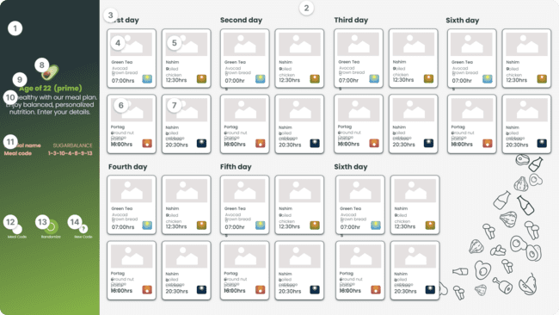**Side Bar**: Holds some vital information about user and important unique codes for later use.
2. **Meal Section**: holds all seven day meals and is the most important for the user.
3. **Day card**: a day card holds four cards which are important meals of that day ,each day card is represented by the title **Number_day** (**first Day**).
4. **First Card of the Day card** (**Breakfast Card**): this is the breakfast card and holds the break fast meal you will have that day and time.
5. **Second Card of the Day card** (**Lunch Card**): this is the lunch card and holds the lunch meal you will have that day and time.
6. **Third Card of the Day card** (**Semi supper Card**): this is the semi supper card and holds the semi supper meal you will have that day and time.
7. **Fourth Card of the Day card** (**Supper Card**): this is the supper card and holds the supper meal you will have that day and time.
8. **Logo**: when clicked leads to the homepage.
9. **Age**: the age entered by the user is displayed here.
10. **Recommendation**: An activity is recommended according to users age.
11. **Special code and name**: this is a special name for your meal and unique numerical code that user should save or write down in order to access the same meal plan.
12. **Meal code Button**: this leads to meal code page where the special code and name should be entered to view users order meal plans
13. **Randomization Button**: this creates a new plan each time user presses it.
14. **New Code Button:** this leads to the get started page.

### **Meal code page**

1. 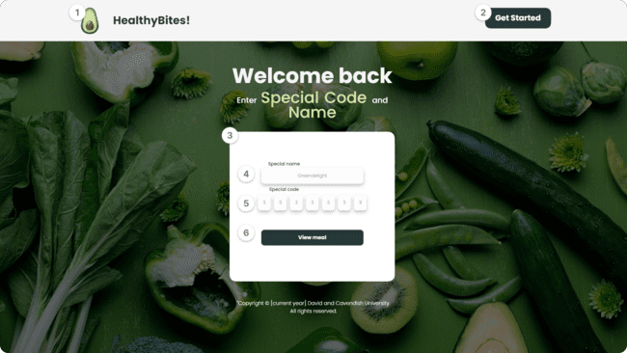**Banner Logo**: this leads to the Home page which is the landing page of the web application.
2. **Banner get started button**: this is a call to action for you to start your meal planning journey.
3. **Returning User Form**: this is where the special code and name is entered.
4. **Special Code**: drop down menu of unique names.
5. **Special code**: this is where you enter the special numerical code.
6. **View meal**: this leads to meal plan with your previous meal.

## Questionnaire and interview Questions

### Questionnaire nutritionist

**Impact of Web Applications on Nutrition**

Assessing the Impact of Web Applications on Nutrition and Healthy Eating Habits in Zambia

* Indicates required question

1. First Name *

|  |
| --- |
|  |

1. Last Name *

|  |
| --- |
|  |

1. Years started working as a Nutritionist *

Example: January 7, 2019

|  |
| --- |
|  |

1. How effective do you believe the usage of the internet, Google and web applications (websites) is in promoting healthy eating habits and improving nutrition among users in Zambia?

|  |
| --- |
|  |
|  |
|  |

1. Based on your interactions with users and clients, what feedback have you received regarding the usage of web applications (website),Internet or Google to access nutrition guides?

|  |
| --- |
|  |
|  |
|  |

1. Have you observed any impact on the nutrition and health status on Individuals who use the internet for nutritional guide?

Mark only one oval.

Yes

No

Maybe

1. From your previous Question what can be the reasons to your answer *

|  |
| --- |
|  |
|  |
|  |

1. In your professional opinion, what are the limitations or areas for improvement in the usage of web applications, such as "Websites," for accessing nutrition guides?

|  |
| --- |
|  |
|  |
|  |

1. What changes or enhancements would you recommend to make web applications * more effective in promoting healthy eating habits and improving nutrition among the Zambian population?

|  |
| --- |
|  |
|  |
|  |

### interview Questions nutritionist

**Impact of nutrition Web Applications guides on Clients**

Assessing the Impact of nutrition Web Applications on clients and patients in Zambia

1. How effective do you believe the usage of the internet, including web applications like "HealthyBites!," is in promoting healthy eating habits and improving nutrition among users in Zambia?
2. Based on your interactions with users and clients, what feedback have you received regarding the usage of web applications, including "HealthyBites!," to access nutrition guides?
3. Have you observed any impact on the nutrition and health status of the users?
4. In your professional opinion, what are the limitations or areas for improvement in the usage of web applications, such as "HealthyBites!," for accessing nutrition guides?

### Interview Questions Citizens

**Impact of nutrition Web Applications guides on Users and nutrition Counseling**

1. What is your perception of the current state of nutrition in Zambia?
2. Do you believe that people in Zambia generally have access to a healthy diet?
3. In your experience, what are the main challenges you face in following a healthy diet in Zambia?
4. Have you encountered any existing solutions or interventions aimed at improving nutrition in Zambia? If yes, please describe them and their effectiveness in your opinion.
5. How familiar are you with the use of technology in improving nutrition?
6. Do you believe that technology can play a significant role in promoting healthy eating habits in Zambia?
7. Are you aware of web applications that offer nutrition guides,? If yes, please share your experience using them and there impact, if any, on your nutrition and health status.
8. In your opinion, what are the limitations or areas for improvement in the web applications?
9. What changes do you think should be made to make them more effective in promoting healthy eating habits and improving nutrition among the Zambian population?
10. How do you believe the web application can have a long-term impact on the nutrition habits of Zambian people?